**VISVESVARAYA TECHNOLOGICAL UNIVERSITY JNANA SANGAMA, BELAGAVI - 590018**



*A Project Report on*

**“Fake News Detection and News Classification Using Machine Learning”**

*Submitted in**partial fulfilment of the requirements for the award of the degree of*

**Bachelor of Engineering**

**In**

**Department of Electronics and Communication Engineering**

for the **Academic Year: 2024-25**

*Submitted by*

**Divya P 1NT21EC045**

**Hamsapriya N 1NT21EC052**

**Kushal K V 1NT21EC072**

*Under the Guidance of*

**Dr. Karunakara Rai B**

Professor

Dept. of Electronics and Communication Engineering



**YELAHANKA, BENGALURU- 560064**



**Department of Electronics and Communication**

***Certificate***

This is to certify that the project work entitled ***“******Fake News Detection and News Classification Using Machine Learning”*** has been carried out by ***Divya P (1NT21EC04), Hamsapriya N (1NT21EC052)*** and ***Kushal K V (1NT21EC072)****,* bonafide students of ***Nitte Meenakshi Institute of Technology****,* in partial fulfillment of the requirements for the award of the degree of **Bachelor of Engineering** in the **Department of Engineering in Electronics and Communication Engineering**, under **Visvesvaraya Technological University**, Belagavi, during the academic year **2024–2025**.

The project report has been examined and approved as it meets the academic requirements specified under the autonomous scheme of **Nitte Meenakshi Institute of Technology** for the said degree.

|  |  |  |
| --- | --- | --- |
| **Signature of the Guide** | **Signature of the HoD** | **Signature of the Principal** |
| **Dr. Karunakara Rai B**  Professor  Dept. of ECE  Nitte Meenakshi Institute of Technology, Bengauru-560064 | **Dr. Parameshachari B D** Professor and Head  Dept. of ECE  Nitte Meenakshi Institute of Technology, Bengauru-560064 | **Dr. H C Nagaraj**  Principal  Nitte Meenakshi Institute of Technology, Bengauru-560064 |

***External Viva-Voce***

***Name of Examiners Signature with Date***

1. **…………………………….. …………………………..**
2. **…………………………….. …………………………..**

##### Acknowledgement

The successful execution of our project has been a significant milestone, and we take this opportunity to express our heartfelt gratitude to all those who have supported and guided us throughout this journey. Whatever we have achieved is the result of their encouragement and help, and we remain deeply thankful to each one of them.

We express our sincere thanks and seek the blessings of **Dr. N. R. Shetty**, Advisor, *Nitte Meenakshi Institute of Technology*, for his vision and emphasis on project-based learning and constructivist principles that have greatly enriched our academic experience. We are grateful to **Mr. Rohit Punja**, Administrator, *Nitte Education Trust*, and **Dr. Sandeep Shastri**, Vice President, *Bangalore Campus, Nitte University*, for their strategic leadership and continued support in fostering academic excellence.

We extend our special thanks to our beloved Principal, **Dr. H. C. Nagaraj**, for providing us with the necessary resources, facilities, and motivation to carry out our project successfully. Our sincere gratitude goes to **Dr. J. Sudheer Reddy**, *Dean – Academics,* and **Dr. Kiran Aithal**, *Dean – Research & Development,* for their guidance, encouragement, and for creating an environment that promotes innovation and academic growth.

We also convey our deep appreciation to **Dr. Parameshachari B D**, **Head of the Department,** *Electronics and Communication Engineering*, for his constant encouragement, valuable guidance, and for fostering a vibrant learning environment. We extend our heartfelt thanks to our project guide, **Dr. Karunakara Rai B**, Professor, *Department of Electronics and Communication Engineering*, for his unwavering support, timely feedback, and insightful mentorship throughout the project. We are also indebted to our parents for their unconditional love, support, and encouragement throughout our academic journey at *Nitte Meenakshi Institute of Technology*, Bengaluru. Finally, we would like to express our appreciation to all those**—named and unnamed—**who contributed in any way to our learning and success.

Divya P (1NT21EC045)

Hamsapriya N (1NT21EC052)

Kushal K V (1NT21EC072)

Date:

##### Abstract

This research offers a thorough method for identifying fake news and classifying authentic news by subject using cutting-edge machine learning and deep learning techniques in light of the growing prevalence of false information on the internet. In order to detect fake news, it starts with conventional models and moves on to more sophisticated techniques like LSTM and BERT, which provide a better contextual knowledge of text. The system employs a hybrid model for news categorisation that combines CNN and BiLSTM with GloVe word embeddings to capture both word order and semantic content. Categories like politics, entertainment, and travel are used to classify real news stories. Since disinformation frequently contains multimedia content, the algorithm also examines related images and sounds to increase the accuracy of identifying fake news. The model also incorporates methods to differentiate between machine-generated and human-written information in order to counter the growing threat of AI-generated fake news. A user-friendly Flask web application that facilitates real-time detection and classification incorporates the full pipeline. Future research will concentrate on enhancing training procedures, learning from fresh data regularly, and monitoring the development of fake news over time. The goal of this system is to be a useful and efficient tool for navigating the complicated world of internet information.

**Contents**

Acknowledgement i

Abstract ii

List of Figures iv

List of Table v

CHAPTER 1 Introduction 1

1.1 Motivation *3*

1.2 Organization of the Report *3*

CHAPTER 2 Literature Survey, Problem Definition and Objectives 4

2.1 Background Work 4

2.2 Open Issues and Challenges 4

2.3 Problem Definition 5

2.4 Objectives 5

2.5 Scope of the Work 6

CHAPTER 3 Design Approach and Methodology 7

3.1 Architecture Diagram7

3.2 Software Description for Proposed methodology 7

3.3 Methodology for fake news detection 8 3.4 Methodology for news classification 11 3.5 Methodology for deepfake audio and image detection 15

CHAPTER 4 Implementation Details 18

CHAPTER 5 Result and Analysis 22

5.1 Model Evaluation for fake news detection 22   
5.2 Model Evaluation for news classification 27

5.3 Deepfake audio and image detection 35

CHAPTER 6 Conclusion and Future Scope 40

Bibliography 43

Publication Details 49

##### List of Figures

Fig 3.1: Proposed model…………………………………………………………………...7

Fig 3.2: Workflow for fake news detection ……………………………………………….8

Fig 3.3: Original Dataset ………………………………………………………………….8

Fig 3.4: Evaluation metrics ………………...……………………………………………10

Fig 3.5: Fake news detection model (best) ………………………………………………11

Fig 3.6: News classification models (functional) ………………………………..………15

Fig 3.7: News classification model (sequential) ………………………...………………16

Fig 3.8: Audio detection model ………………………………………………………….16

Fig 5.1: Training loop with LSTM for W2V ……………………………………………23

Fig 5.2: Training loop for fake news detection ……………………………………….....23

Fig 5.3: FPR & Recall ……………………………………………………………….…..23

Fig 5.4: Fake News Detection Word Count …………………………………..…………24

Fig 5.5: Fake Word Cloud ……………………………………………………………….24

Fig 5.6: Real Word Cloud ………………………………………………………...……..24

Fig 5.7: Accuracy and loss graph …………………………………………………..……25

Fig 5.8: Random Forest TPR vs FPR …………………………………………...……….25

Fig 5.9: Confusion matrix for Real and Fake ……………………………………………25

Fig 5.10: LSTM TPR vs FPR Graph …………………………………………………….25

Fig 5.11: LSTM W2V Classification report …………………………………….……….26

Fig 5.12: LSTM W2V Accuracy and loss graph ………………………………...………26

Fig 5.13: LSTM Glove Confusion matrix …………………………………………….....27

Fig 5.14: News Classification Dataset …………………………………………..………27

Fig 5.15: Pie chart Categories of Fake News …………………………………..………..28

Fig 5.16: Bar Graph Categories of Fake News ……………………………………...…..28

Fig 5.17: Classification Report ……………………………………………………….…29

Fig 5.18: Pie Chart representing Real vs Fake ……………….………………………….30

Fig 5.19: Distribution of News Articles by Subject Category in the Fake News Detection Dataset …………………………………………………………………………….……..30

Fig 5.20: Accuracy and Loss Graph …………………………………………………..…30

Fig 5.21: Confusion Matrix …………………………………………………………...…30

Fig 5.22: News classification Accuracy vs no. of epoch curve …………………….……31

Fig 5.23: Logistic regression ……………………………………………………...……..32

Fig 5.24: Decision tree ……………………………………………………………….….32

Fig 5.25: Gradient boosting ………………………………………………………..…….32

Fig 5.26: Random forest …………………………………………………………..……..32

Fig 5.27: Roc curve random forest ………………………………………………..……..33

Fig 5.28: HTML website …………………………………………………………..…….33

Fig 5.29: News Detection Frontend ……………………………………………….…….34

Fig 5. 30: Fake news prediction result …………………………………………..………34

Fig 5.31: Image Detection ………………………………………………………...……..35

Fig 5.32: Image detection training loop ………………………………………...……….36

Fig 5.33: Image detection accuracy curve …………………………….………..………..36

Fig 5.34: Image Detection Classification Report ………………………………………..36

Fig 5.35: Image detection Confusion matrix ……………………………….……..……..37

Fig 5.36: Audio detection example spectrogram ……………………………….…..……38

Fig 5.37: Audio detection data class distribution bar graph ……………………………..39

Fig 5.38: Audio detection training loop…………………………………………...……..39

# Chapter 1 Introduction

In the digital age, the explosion of user-generated content and the rapid dissemination of information via social media platforms and online news portals have brought unprecedented access to information. While this democratization of content has empowered individuals, it has simultaneously introduced significant challenges, primarily in the form of fake news and deepfakes. These manipulated forms of content—ranging from misleading articles to synthetically generated audio and images—pose serious threats to information integrity, public trust, and democratic processes.

Fake news is intentionally crafted misinformation that mimics legitimate news in form but not in content or intent. It has become a potent tool for political propaganda, financial fraud, social manipulation, and cultural division. The global impact of such content was especially visible during major political events, health crises, and national emergencies. Similarly, deepfake technology, which uses deep learning algorithms to manipulate visual and auditory data, has seen a rise in sophistication, enabling the creation of hyper-realistic fake videos and audios that are difficult to distinguish from authentic ones. These developments necessitate robust and intelligent systems that can accurately detect and mitigate the effects of manipulated content in real-time.

This project aims to build a comprehensive AI-based system to detect both fake news and deepfake content using advanced machine learning (ML) and deep learning (DL) techniques. The system comprises multiple components, each tailored to handle different data modalities—text, image, and audio. Our approach leverages both traditional ML algorithms and modern DL architectures, enabling the system to understand context, detect semantic inconsistencies, and identify synthetic patterns.

The fake news detection module employs a wide range of algorithms starting from classical classifiers like Logistic Regression, SVM, Random Forest, and XGBoost, to more advanced neural architectures such as CNNs, BiLSTMs, and transformer-based models like BERT. The objective is to evaluate the trade-offs between speed, interpretability, and accuracy while experimenting with various input representations such as TF-IDF, GloVe, and Word2Vec embeddings. Attention mechanisms and hybrid models are also explored to enhance contextual understanding of text and improve classification performance.

In parallel, the deepfake detection component focuses on both audio and image data. For image-based detection, convolutional neural networks are trained on datasets containing authentic and manipulated images. Augmentation techniques are used to improve model generalization, while explainability tools like Grad-CAM are employed to interpret the regions the model focuses on. On the other hand, deepfake audio detection is performed by converting audio samples into spectrograms and training CNN-based models on these time-frequency representations. Libraries such as Librosa are used for feature extraction, and performance is evaluated using metrics like accuracy, AUC, and precision-recall curves.

The entire system is implemented in Python, taking advantage of its extensive ecosystem of libraries including TensorFlow, Keras, Scikit-learn, NLTK, spaCy, Pandas, NumPy, and Matplotlib. Development and experimentation are carried out in Jupyter Notebooks for efficient visualization and iteration. Model evaluation includes metrics like accuracy, precision, recall, F1-score, and confusion matrices to ensure fair performance assessment across all classes. For model interpretability and deployment readiness, steps such as checkpointing, early stopping, and hyperparameter optimization are integrated into the training workflow.

In addition to performance evaluation, this report also explores challenges such as imbalanced datasets, overfitting, lack of contextual cues, and the evolving nature of misinformation. Strategies like Bayesian Optimization, data augmentation, and attention-based refinement are incorporated to overcome these limitations. Furthermore, the deployment perspective is considered by prototyping model-serving APIs using Flask and exploring inference optimization techniques for real-time applications.

The outcomes of this project have far-reaching implications across domains such as media verification, cybersecurity, legal systems, education, and public policy. A system that can accurately and efficiently detect fake content across different formats is not only a technical achievement but also a societal necessity in the modern digital ecosystem.

In summary, this report presents a unified framework for fake content detection that combines the strengths of machine learning, deep learning, and natural language processing. Through rigorous experimentation, cross-modal analysis, and model interpretability, it aims to contribute to the ongoing global effort to uphold digital truth and safeguard the integrity of online information.

## Motivation

In recent years, content-based recommender systems have played a pivotal role in enhancing user experience across digital platforms by delivering personalized content tailored to individual preferences. These systems improve user satisfaction by continuously presenting content aligned with previous interactions such as likes, shares, and comments. However, this mechanism has inadvertently opened the door for a new challenge: the amplification of misinformation, particularly fake news.

Once a user engages with misleading or false content, recommender systems tend to perpetuate similar content, regardless of its authenticity. This feedback loop not only reinforces false narratives but also contributes to the widespread dissemination of fake news. In some instances, users have even learned to manipulate these systems, intentionally curating the kind of content they wish to see and suppressing dissenting or unwanted information.

## Organization of the Report

The report is organized into several key sections to provide a clear and structured overview of the fake news detection project. It begins with an Introduction, outlining the problem statement, objectives, and the significance of detecting fake news. This is followed by a Literature Review, summarizing existing approaches and research in the domain. The Methodology section describes the dataset, preprocessing steps, feature extraction techniques, and the machine learning models used, including logistic regression. The Results and Discussion section presents the evaluation metrics, performance analysis, and visualization of results such as ROC and precision-recall curves. Finally, the report concludes with a Conclusion and Future Work, highlighting key findings, limitations, and possible directions for improvement.

# Chapter 2 Literature Survey

## 2.1 Background Work

Over the past decade, the rapid rise of social media and online news platforms has significantly influenced how information is consumed and shared. Early fake news detection methods mainly focused on analyzing textual content using natural language processing (NLP) techniques. Linguistic patterns, grammatical inconsistencies, and sensational language were among the primary indicators used to flag potentially misleading articles. Several models employed traditional machine learning classifiers such as Naive Bayes, Decision Trees, and Support Vector Machines, trained on labeled datasets of real and fake news.

However, as fake news creators began to adopt more advanced content strategies, these basic models started to fall short. To enhance detection, researchers introduced hybrid approaches that combined text features with metadata, such as publication date, source credibility, and user engagement metrics. Some models integrated social context by analyzing the behavior of users who engage with fake news, including their interaction patterns, social network positions, and content sharing frequency.

Recently, the adoption of deep learning architectures such as Convolutional Neural Networks (CNNs) and Recurrent Neural Networks (RNNs) has improved model performance, especially when applied to multimodal data including images and videos. Graph-based approaches have also gained traction, focusing on how fake news spreads through online communities, often forming tight-knit clusters of like-minded users.

## 2.2 Open Issues and Challenges

Despite advancements, several challenges continue to hinder effective fake news detection. One major issue is the dynamic nature of misinformation. Fake content evolves quickly, often outpacing the datasets and models designed to detect it. Models trained on static datasets may fail when exposed to new, unseen misinformation patterns.

Another critical issue is the limited availability of high-quality, annotated datasets that include multimodal and behavioral features. Most datasets focus exclusively on text, overlooking the visual and social aspects of misinformation. Furthermore, the presence of AI-generated content complicates the landscape, as this content often mirrors the tone and structure of legitimate news, making it harder to distinguish through linguistic analysis alone.

Bias and overfitting are also pressing concerns. Many models show high accuracy during testing but fail in real-world applications due to poor generalizability. Additionally, there’s an increasing need to detect not only the content itself but the intent and patterns of the accounts spreading it—something most existing systems do not fully address.

Most existing fake news detection techniques primarily focus on linguistic or textual analysis. While useful, these approaches overlook other vital aspects such as user behavior and the network structures that facilitate the spread of misinformation. Additionally, there has been limited consideration of the characteristics of the information recipients—those who engage with and propagate content further. Without understanding the broader social and behavioral context, these detection methods fall short in providing comprehensive solutions to a complex and evolving problem.

## 2.3 Problem Definition

Traditional fake news detection models, while effective to some extent, are limited by their narrow focus on linguistic analysis. They often neglect critical elements such as the characteristics of the users sharing the content, the structure and behavior of the social networks involved, and the visual or stylistic features of the news itself. As fake news becomes more refined and AI-generated, these limitations significantly reduce the models’ ability to detect misinformation accurately.

This research addresses the problem by proposing a multi-dimensional model that incorporates visual, user-based, and network-level features, aiming to build a more robust and scalable solution for fake news detection.

## 2.4 Objectives

The aim of this study is to investigate the impact of multimodal features—textual, visual, behavioral, and network-based on the effectiveness of fake news detection systems and to develop a model that improves predictive accuracy by incorporating these features.

To achieve this aim, the study is structured around the following objectives:

* To conduct a review of existing fake news detection techniques and identify their limitations, particularly with respect to content-only analysis.
* To extract and engineer a diverse set of features, including user metadata, network structure, and visual content.
* To employ **XGBoost** for selecting the most relevant features that significantly contribute to the classification of fake news.
* To train and evaluate five different machine learning models—Logistic Regression, Neural Network, Random Forest, Support Vector Machine, and CART—using the selected features.
* To compare the models' performance and determine which combination of features and algorithms yields the most reliable results.
* To provide insights and recommendations for developing more robust detection frameworks that can adapt to evolving patterns of misinformation.

## 2.5 Scope of the Work

This research is limited to the development and evaluation of a machine learning model for fake news detection based on multimodal data. The study does not aim to create a real-time detection system, nor does it cover multilingual misinformation or region-specific datasets. However, it sets the groundwork for future research in those areas by establishing a scalable approach that includes behavioral and social factors, often overlooked in current methodologies.

The work primarily focuses on offline model training and evaluation using annotated datasets. Future extensions could involve integrating deep learning methods, real-time data streams, and the development of browser-based detection tools.

# Chapter 3 Design Approach and Methodology

## 3.1 Architecture Diagram

Block diagram of Project work is given below:

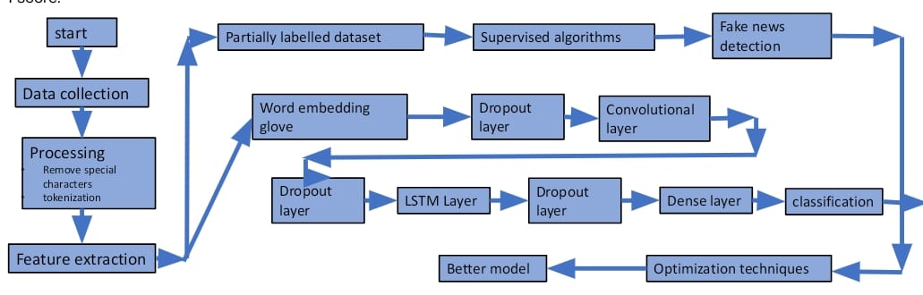

Fig 3.1: Proposed model

The diagram outlines a structured workflow for detecting fake news using both machine learning and deep learning techniques. The process begins with data collection, where relevant information, often from news articles or social media, is gathered. Once collected, the data undergoes a pre-processing phase, which includes cleaning steps such as removing special characters and tokenizing text to make it suitable for analysis.

After cleaning, the next step is feature extraction, which helps in identifying key characteristics from the text data. At this stage, the data can take two parallel paths:

1. Traditional Machine Learning Path:

A portion of the data that has partial labels is fed into supervised learning algorithms, which learn to distinguish between real and fake news. The result of this training is then used for fake news detection.

1. Deep Learning Path:

Another path involves using word embeddings, such as GloVe, to convert text into numerical vectors. These embeddings go through multiple layers:

Dropout layers to prevent overfitting,

Followed by either a Convolutional Neural Network (CNN) path for capturing spatial features or a Long Short-Term Memory (LSTM) path to understand the sequence and context in text.

The LSTM path also includes additional dropout and dense layers for further processing before leading to classification.

The outcomes of both paths are evaluated to determine how well they perform. To further improve performance, optimization techniques are applied, aiming to build a better model. This optimized model feeds back into the classification or fake news detection process, completing the loop.

## 3.2 Software Description for Proposed methodology

* **Programming Language:** Python for implementing the machine learning and deep learning algorithms.
* **Libraries and Frameworks:**
* **TensorFlow/Keras** or **PyTorch**: For building and training deep learning models.
* **NLTK** or **spaCy**: For natural language processing tasks such as tokenization, stemming, and lemmatization.
* **Scikit-learn**: For implementing traditional machine learning models and evaluation metrics.
* **Pandas**: For data manipulation and analysis.
* **NumPy**: For numerical computing and handling arrays.
* **Jupyter Notebook**: For interactive coding, visualization, and documentation.

## 3.3 Methodology for fake news detection

## 

Fig 3.2: Workflow for fake news detection

**Dataset selection**: The ISOT dataset was chosen as our base dataset, with no restrictions on incorporating additional data. However, since the ISOT dataset predominantly covers limited domains—specifically, politics and world news related to US and Middle-East governments—we explored integrating additional datasets to broaden the coverage. Each additional dataset required distinct pre-processing techniques before they could be merged. This integration will be refined and implemented in later stages as we work toward finalizing and deploying the complete project.

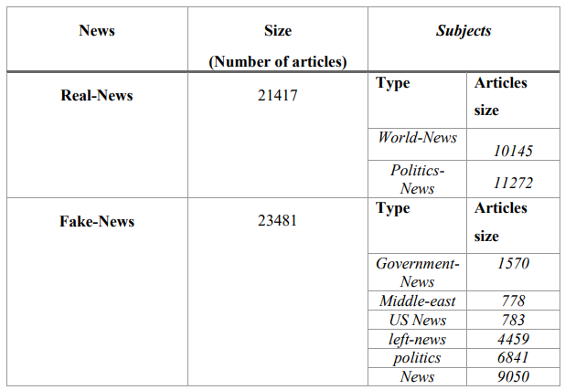

Fig 3.3: Original Dataset

**Exploratory Data Analysis:** Our machine learning development process centered on exploratory data analysis (EDA) and data preprocessing as core building blocks. These processes preprocessed our dataset by identifying the most important classification features before model training. We began employing basic ML algorithms like Logistic Regression, Support Vector Classifiers, XGBoost, Passive Aggressive Classifiers, and Random Forests, implementing preprocessing techniques like regex pattern matching and case normalization to strip clean symbols and links from our text data.

During initial model testing, we had unrealistically high accuracy of 99% and above, which suggested possible data leakage or the lack of sufficient preprocessing. We were thus forced to re-evaluate our EDA process and found some crucial differences between genuine and fake news classes (i.e., mean words per sentence, article length, and patterns of content). Normalizing the features helped us eliminate these overfitting variables successfully.

While technically superior accuracy was achieved, our models were not able to make reasonable predictions on recent news articles. We attributed that failure to either the absence of semantic learning potential in vanilla ML models or to bad training data. We were therefore encouraged to move to deep learning frameworks where we leveraged the stronger feature learning foundation of neural networks.

To apply deep learning, we tried various word embedding methods:

* + GloVe (Global Vectors for Word Representation) through matrix factorization across word-context matrices
  + Word2Vec using Continuous Bag of Words (CBOW) and Skip-gram model - One-Hot Representations and tokenizers for categorical encoding

The GloVe embeddings yielded our highest performance, 98.11% test accuracy and 98.06% validation accuracy with uniform model architecture for all embedding techniques.

In search of stronger semantic understanding capability, we ultimately chose BERT (Bidirectional Encoder Representations from Transformers), an advanced NLP model pretrained on the Wikipedia corpus. In the performance vs. computational cost trade-off, we employed a lighter version of BERT rather than the full 340M parameter model. As pre-processing, we employed BertTokenizerFast utilizing subword tokenization on the 'Title' column rather than the full 'Text' content of a news article.

**Metric and model selection:** After extensive trial with other machine learning and deep learning methods, we chose the 'bert-base-uncased' transformer model as our best choice. It has 12 encoders with 12 bidirectional self-attention heads and 110 million parameters. We chose this configuration over 'bert-large-uncased' (340 million parameters with 24 encoders and 16 self-attention heads) deliberately to trade performance with computational expense. Although the bigger model may result in slight accuracy gain, the base model yielded significant computational gains without loss of performance. Pre-training of BERT on Toronto BookCorpus (800M words) and English Wikipedia (2,500M words) provides it with strong semantic understanding abilities needed for subtle fake news identification. When we experimented with custom models trained from scratch on our data, we observed the pre-trained BERT models to perform significantly better.

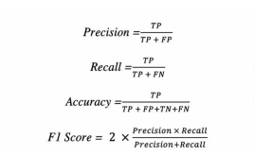

Fig 3.4: Evaluation metrics

**Model architecture:**

1. **Input Layer:** Accepts raw text data (news articles).
2. **Text Preprocessing:**

* **Tokenization:** Splitting the text into words or tokens.
* **Lowercasing:** Converting all characters to lowercase.
* **Stop-word Removal:** casual words removal that add little value to the analysis (e.g., "and," "the").
* **Lemmatization/Stemming:** Reduction of words to their base or root form.

1. **Embedding Layer:** Word embeddings (e.g., **Word2Vec**, **GloVe**, or **FastText**) to convert words into dense vectors that capture semantic meanings.
2. **Models:**

* Supervised learning models: Logistic Regression, Support Vector Classifiers, XGBoost, Passive Aggressive Classifiers, and Random Forests.
* Deep learning models: BERT(standalone model), LSTM, BERT with tf-idf vectorization

1. **Attention Mechanism:** Computes attention scores to measure the significance of different parts of the input data, allowing the model to focus on relevant features during classification.
2. **Output Layer:** A softmax layer that outputs the probability of the data being real news or fake news.
3. **Loss Function:** Cross-entropy loss function for binary classification.
4. **Training & Evaluation:** model training using labelled datasets and evaluate it using metrics like accuracy, precision, recall, and F1 score.

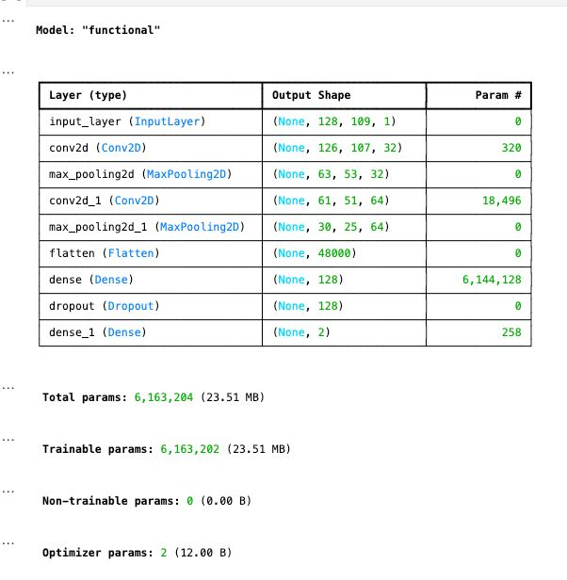

Fig 3.5: Fake news detection model (best)

**3.4 Methodology for news classification**

**Dataset selection**: The News Category Dataset was chosen which is a comprehensive collection of news articles organized by topic categories. It serves as a crucial asset for NLP tasks such as text classification, topic modelling, and content analysis. The dataset contains thousands of headlines and article descriptions from various news sources, spanning multiple years of publication.

**Exploratory Data Analysis:** The dataset is structured as a collection of news articles with the following key attributes:

* Category: The topical classification of the news article (e.g., Politics, Business, Entertainment, Technology)
* Headline: The title of the news article
* Description: A brief summary or the first few sentences of the article content
* Date: The publication date of the article
* Source: The news outlet or publisher that released the article

The dataset includes a diverse range of news variants that includes but does not end at Politics, Business, Technology, Entertainment, Sports, Health, Science, World News, Education, Environment, Crime, Travel. The dataset approximately 200,000 news articles, News articles from 2012 to 2022 ,category distribution varies across categories with Politics, Entertainment, and Business having the highest representation, Average Headline Length is 12 words and Average Description Length is 28 words.

**Applications:** This dataset is particularly suitable for:

1. Developing news classification systems
2. Training content recommendation algorithms
3. Studying linguistic patterns in headlines
4. Analyzing temporal trends in news coverage
5. Research on media bias and framing
6. Sentiment analysis across different news topics

**Data Quality:** The dataset has undergone cleaning processes to ensure consistency, including:

* Removal of duplicate entries
* Standardization of category labels
* Verification of date formats
* Basic text normalization

**Limitations**

* The dataset may contain some imbalance in category representation
* Some articles may be misclassified or contain ambiguous content
* Regional or cultural bias may exist due to source selection
* Newer articles may not be included beyond the dataset's collection period

This dataset provides an excellent foundation for text classification tasks and offers valuable insights into news content organization and presentation across various domains and time periods.

**Metric and model selection:** After extensive experimentation on various architectures, we initially employed the hybrid deep learning model of CNN and BiLSTM with BERT embeddings for news classification. Despite theoretical advantage of contextual representations of BERT, we observed poor performance with this model. Further probing led us to switch to a CNN-BiLSTM hybrid model with GloVe embeddings later on. This architecture change led to much improved accuracy metrics for all categories of news. The GloVe-based model demonstrated enhanced feature extraction capability, with the CNN component effectively extracting local text features and the BiLSTM layers extracting sequential data and long-term dependencies properly. While BERT embeddings offered richer semantic comprehension in theory, the GloVe embeddings (trained on a 6 billion token corpus) were more helpful for our required classification task when used with our CNN-BiLSTM architecture. This difference in performance might be attributed to enhanced compatibility of GloVe's static word representations with the architectural environment of our model, leading to more successful training and improved generalizability to new articles.

**Model architecture:**

1. **Input Layer:** Accepts raw text data (news articles).
2. **Text Preprocessing:**
   1. **Tokenization:** Splitting the text into words or tokens.
   2. **Lowercasing:** Converting all characters to lowercase.
   3. **Stop-word Removal:** Removal of casual words that add little value to the analysis (e.g., "and," "the").
   4. **Lemmatization/Stemming:** Reducing words to their base or root form.
3. **Embedding Layer:** Word embeddings (GloVe) to convert words into dense vectors that capture semantic meanings.
4. **CNN Layer:** Convolutional layers for capturing local patterns and n-grams from the text and also feature extraction.
5. **Max-Pooling layers** to down-sample the feature maps.
6. **Bi-LSTM Layer:** Processes sequences in both forward and backward directions, capturing long-term dependencies in the text.
7. **Attention Mechanism:** Computes attention scores to measure the significance of different parts of the input data, allowing the model to focus on relevant features during classification.
8. **Fully Connected Layer:** A dense layer that combines the extracted features from CNN and Bi-LSTM layers, followed by an activation function (e.g., GeLU).
9. **Output Layer:** A softmax layer that outputs the probability of the input being real news or fake news.
10. **Optimization Techniques:** Bayesian Optimization and Grasshopper Optimization Algorithm for hyperparameter tuning. The Hyperparameters are

* max_length: 256
* learning rate calculation: Dynamic
* optimizer: adamw
* Batch size: 32 to 64,
* Epochs: 6 to 10

1. **Loss Function:** Cross-entropy loss function for binary classification.
2. **Training & Evaluation:** model training using labelled datasets and evaluate it using metrics like accuracy, precision, recall, and F1 score.

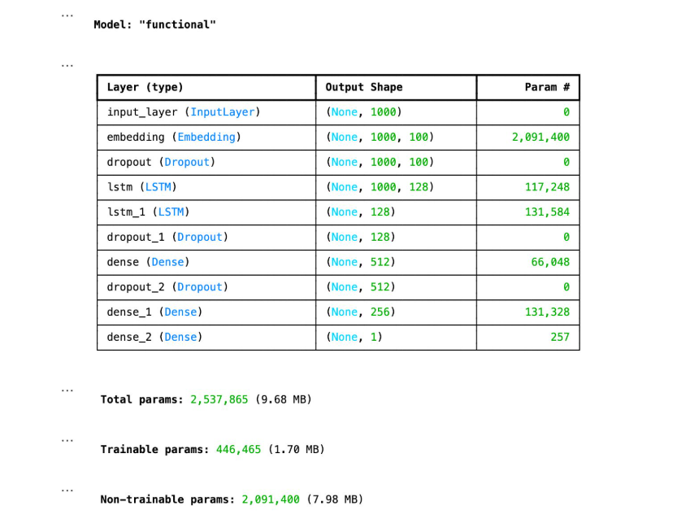

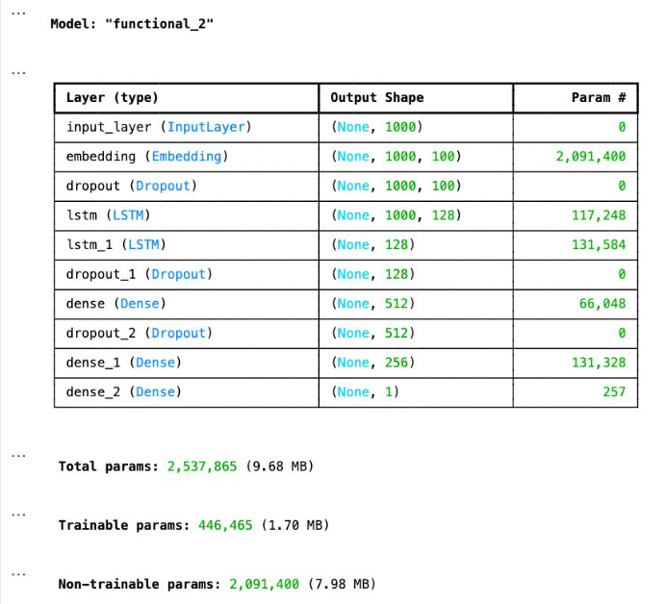

Fig 3.6: News classification models

**3.5 Methodology for deepfake audio and image detection**

**Dataset Selection:** Asvspoof dataset for audio detection and real_fake_images dataset for deepfake image detection.

**Model architecture:**

* **CNN Layer:** Convolutional layers for feature extraction, capturing local patterns and n-grams from the text.
* **Max-Pooling layers** to down-sample the feature maps.
* **Fully Connected Layer:** A dense layer that combines the extracted features from multiple CNN layers.

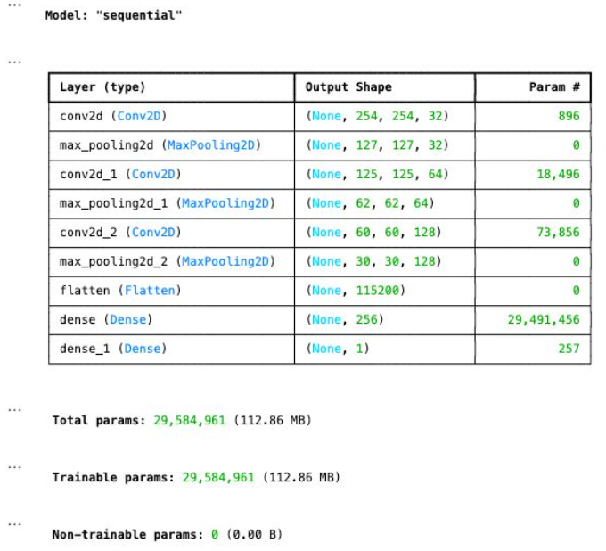

Fig 3.7: News classification model (Sequential)

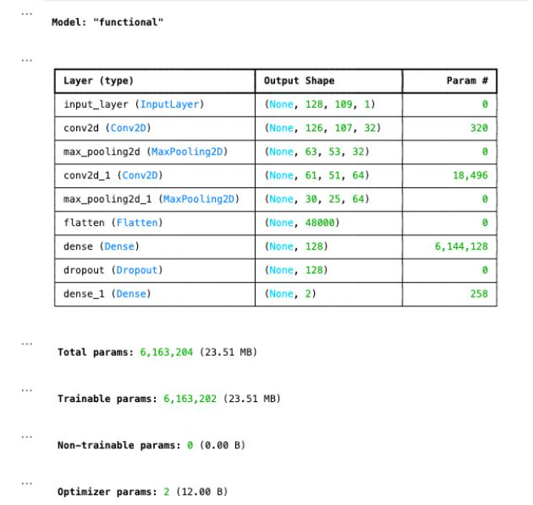

3.8 Audio Detection Model

This section also illustrates the design philosophy, data workflows, and architectural decisions behind the various subsystems developed in this project. The figures included here serve not as standalone images but as part of a cohesive narrative that maps the journey from raw data to deployable models. They encompass key stages including the formulation of the proposed model, preprocessing logic, representation of datasets used, and high-level overviews of deep learning architectures tailored for specific tasks like fake news detection, news classification, and audio analysis.

Together, these visuals establish the foundational framework of the work, helping to clarify how different components interact, how information flows through the system, and how decisions regarding model selection, embedding techniques, and network configurations were approached. They are intended to make the experimental design transparent and replicable while justifying the transition from traditional models to more sophisticated deep learning architectures.

# Chapter 4 Implementation Details

The entire system was developed and implemented using Python, chosen for its versatility and comprehensive ecosystem of libraries tailored for machine learning (ML) and deep learning (DL) applications. Model development, experimentation, and analysis were conducted in Jupyter Notebooks, which provided an interactive and integrated environment for code execution, visualization, and documentation, significantly enhancing productivity and reproducibility.

For the deep learning components of our work, we primarily used TensorFlow and its high-level API, Keras, due to their ease of use, scalability, and wide community support. Traditional machine learning models were implemented using Scikit-learn, which offers a rich set of algorithms and tools for tasks such as classification, model evaluation, and feature engineering.

In terms of data preprocessing, especially for the text-based components, we employed Natural Language Processing (NLP) libraries such as NLTK and spaCy. These libraries enabled us to perform crucial preprocessing steps including tokenization, lemmatization, stop-word removal, and POS tagging, which are essential for converting raw text into a machine-understandable format. We also utilized Pandas for data manipulation and NumPy for efficient numerical computations.

The fake news detection module began with the implementation of several classical ML algorithms to establish baseline performance benchmarks. These included Logistic Regression, Support Vector Machines (SVM), XGBoost, Passive Aggressive Classifiers, and Random Forests. While these models achieved reasonable results, they exhibited limitations in semantic comprehension and struggled with generalizing to more complex and contextual language patterns.

To address these issues, we transitioned to deep learning architectures, leveraging advanced word embeddings such as GloVe and Word2Vec. These embeddings enabled the model to capture contextual relationships and semantic similarities between words. We achieved our best results using BERT (Bidirectional Encoder Representations from Transformers), particularly when employing subword tokenization, which significantly improved the model’s ability to handle unseen or rare words. Focusing on article titles rather than the full text improved processing speed while retaining essential semantic cues, leading to more efficient inference.

For the news classification task, we designed a hybrid deep learning model combining CNN and BiLSTM layers supported by GloVe embeddings. The CNN layers captured local n-gram features, while the BiLSTM layers modeled sequential dependencies in the text. To enhance the model’s interpretability and performance, we integrated attention mechanisms that allowed the network to focus on the most relevant parts of the input. Hyperparameter tuning was performed using advanced techniques such as Bayesian Optimization and the Grasshopper Optimization Algorithm, helping us fine-tune model parameters for optimal results.

The deepfake detection module consisted of two parallel pipelines for audio and image detection. For audio deepfakes, we trained CNN-based models on the ASVspoof dataset, converting voice samples into spectrograms to allow the model to learn time-frequency patterns. For image deepfakes, we used a custom real_vs_fake image dataset, training convolutional networks to distinguish between authentic and manipulated visual content based on learned features.

Throughout the project, all models were rigorously evaluated using standard classification metrics including accuracy, precision, recall, and F1-score, measured across multiple runs to ensure robustness, consistency, and generalizability. These evaluations were complemented by visual tools such as confusion matrices, ROC curves, and precision-recall curves to gain deeper insights into model behavior and performance trade-offs.

To manage experimentation at scale and ensure reproducibility, we structured our codebase into modular scripts separating data preprocessing, model training, evaluation, and utility functions. This modular approach made it easier to test variations in model architecture, embeddings, and hyperparameters across different components of the system. We also employed version control using Git to track code changes and enable collaborative development.

In our deep learning pipelines, early stopping and model checkpointing were implemented to avoid overfitting and preserve the best-performing model weights during training. Batch normalization and dropout layers were incorporated within CNN and BiLSTM architectures to stabilize training and improve generalization. For training acceleration and GPU utilization, we ran most deep learning experiments on Google Colab Pro and Kaggle Notebooks, both of which provided GPU access and were integrated with our datasets stored in cloud platforms such as Google Drive.

The attention mechanism added to the hybrid CNN-BiLSTM model significantly improved performance by allowing the network to learn which parts of the input carried the most critical information for classification. This was particularly effective in dealing with lengthy and noisy input sequences commonly found in news articles.

For the BERT-based experiments, we utilized Hugging Face’s Transformers library, which enabled us to load pre-trained models like bert-base-uncased with ease and fine-tune them for our classification tasks. We also experimented with training configurations, such as learning rate schedules, optimizer choices (e.g., AdamW), and warm-up steps to maximize BERT's potential on our data.

The spectrogram generation for deepfake audio detection was done using Librosa, a powerful Python library for audio and music analysis. We applied Mel spectrograms and log-scaled frequency features to feed into our CNN models, which proved effective in identifying synthetic audio patterns that deviate subtly from natural speech. Data augmentation techniques such as pitch shifting and noise injection were explored to improve the robustness of the audio classifier.

For deepfake image detection, we employed data augmentation techniques including horizontal flipping, brightness adjustment, and random cropping using Keras' ImageDataGenerator to make the model more resilient to unseen variations. We used ResNet and EfficientNet as base CNN architectures for experimentation and evaluated performance differences in terms of convergence speed and generalization.

To support model interpretability, we also generated Grad-CAM (Gradient-weighted Class Activation Mapping) visualizations for CNN-based image detection, highlighting the regions in an image that contributed most to the model’s classification decision. This helped validate that the model was learning meaningful features rather than relying on artifacts or biases in the dataset.

To ensure our models could be adapted or deployed in real-world scenarios, we saved them in portable formats such as .h5 (Keras) and .pkl (Scikit-learn), and used Flask to prototype lightweight REST APIs for serving inference requests. We also documented the training and evaluation processes, hyperparameter configurations, and outcomes using Markdown cells in Jupyter and generated interactive visualizations with Matplotlib, Seaborn, and Plotly for reporting purposes.

Finally, we adopted a comprehensive validation strategy by splitting datasets into training, validation, and test sets with stratified sampling where applicable, and conducted cross-validation for traditional models to minimize variance in evaluation. These practices ensured that the results we obtained were both statistically reliable and representative of real-world performance.

# Chapter 5 Result and Analysis

**5.1 Model Evaluation for fake news detection:**

For our machine learning-based fake news detection system, we evaluated model performance primarily using the accuracy score and other important metrics derived from the confusion matrix, including precision, recall, and F1-score. Our initial experiments on binary classification tasks yielded an average accuracy of 92.17% and an AUC (Area Under the Curve) score of 0.8, indicating a strong discriminatory capability of the models.

Model evaluation was also carried out by tracking metrics such as training and validation loss, and comparative analysis of feature representation methods. Notably, we achieved our best performance using GloVe (Global Vectors for Word Representation) embeddings, which delivered a remarkable 97.86% accuracy on the training dataset and 97.81% on the testing dataset, highlighting the effectiveness of pre-trained word embeddings in capturing semantic relationships.

In addition, we explored state-of-the-art (SOTA) transformer-based models such as BERT (Bidirectional Encoder Representations from Transformers). While BERT achieved a comparatively lower accuracy of 89%, it demonstrated superior performance when tested on contemporary news data, making it highly adaptable and context-aware. Moreover, when we combined TF-IDF (Term Frequency-Inverse Document Frequency) embeddings with the BERT architecture, the model achieved an improved accuracy of 93.59% in just one epoch of training. This suggests significant potential for even higher accuracy if trained over multiple epochs (5–10), indicating that hybrid embedding techniques may enhance model efficiency and generalization capability.

These results emphasize the importance of both classical and modern NLP techniques and show how strategic combinations can improve fake news detection performance significantly.

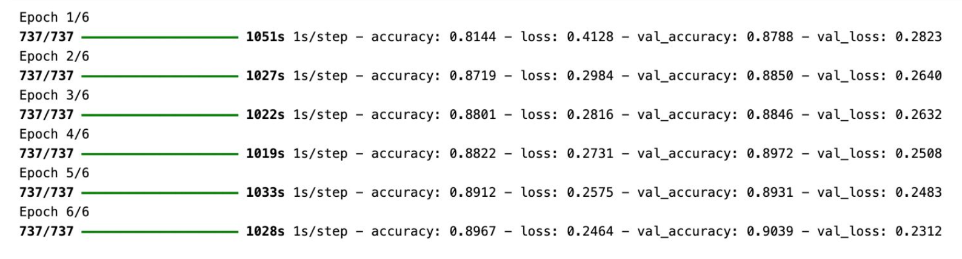

Fig 5.1: Training loop with LSTM for W2V

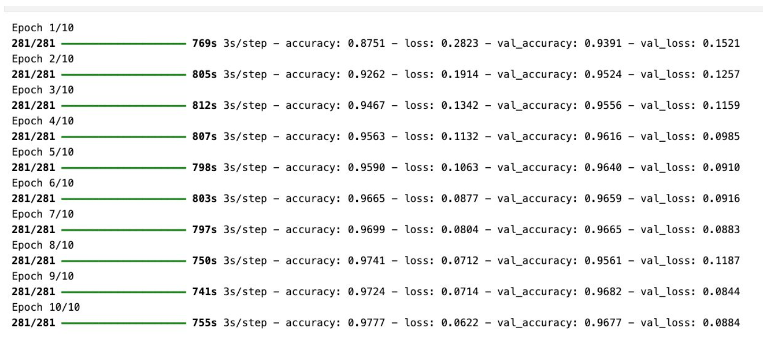

Fig 5.2: Training loop for fake news detection

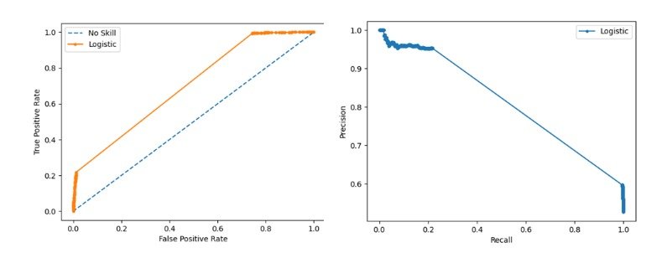We also tried training on other transformer-based models such as DistilBERT & RoBERTa but were not able to wrap it up completely.

Fig 5.3: FPR & Recall

These visuals (Fig 5.1 to 5.3) capture the training behavior and performance validation for various fake news detection models. They help identify learning patterns, convergence speed, and classification strength.

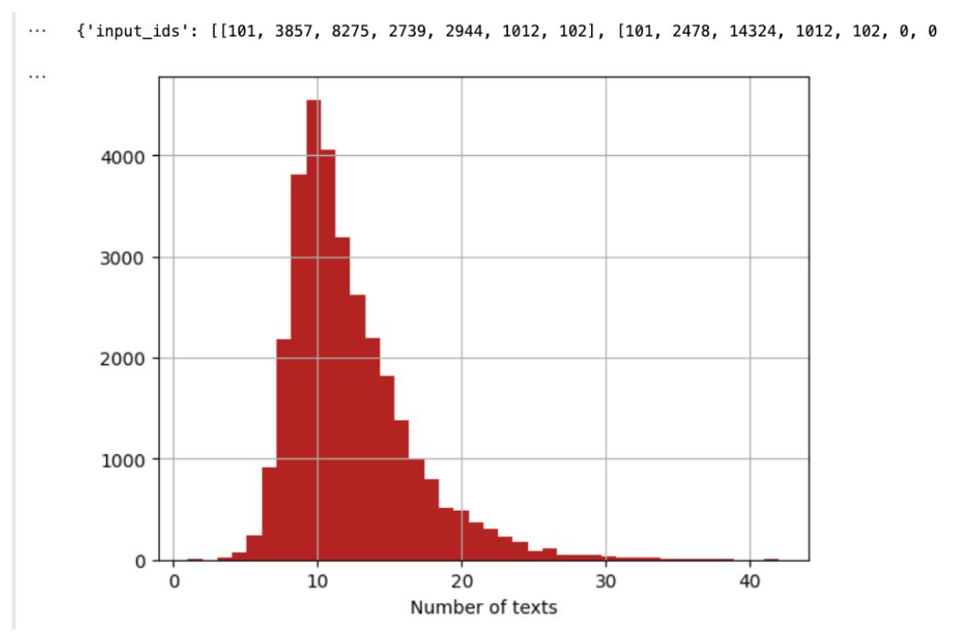

Fig 5.4: Fake News Detection Word Count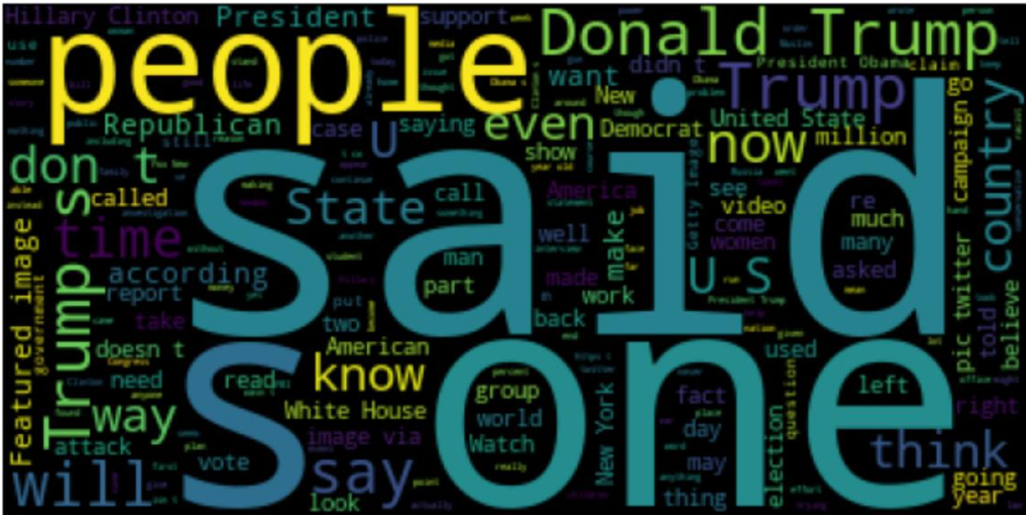

Fig 5.5: Fake Word Cloud

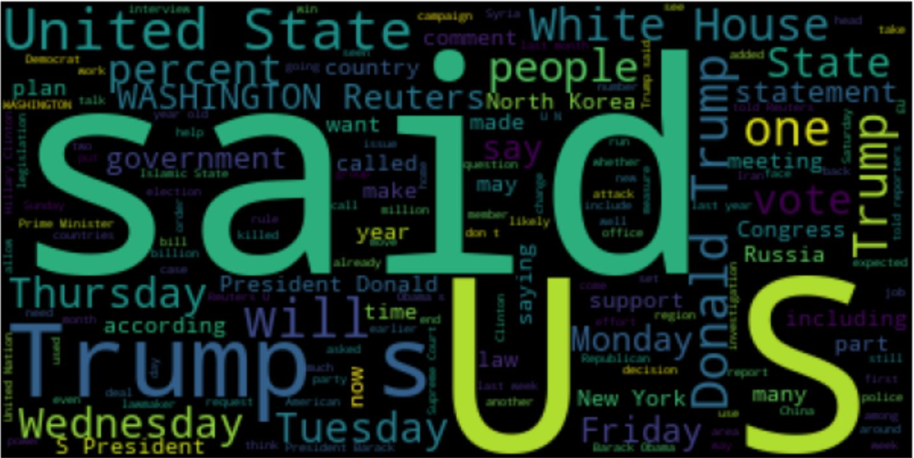

Fig 5.6: Real Word Cloud

Word clouds and frequency plots (Figures 5.4 – 5.6 (Text Visualizations)) give insight into the linguistic patterns within the fake and real news datasets. These representations help explain model focus areas and common cues in text.

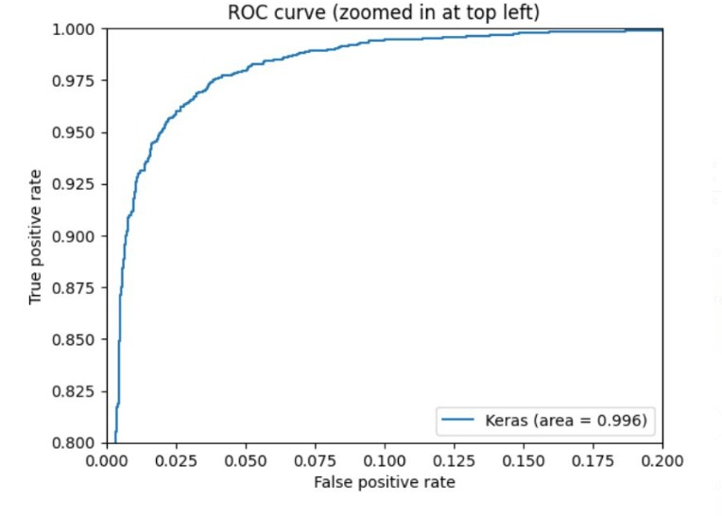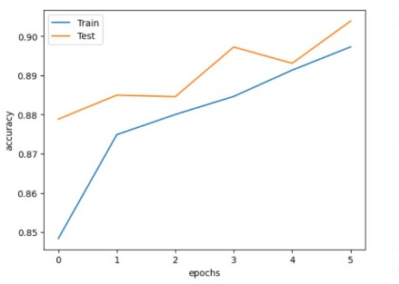

Fig 5.7: Accuracy and loss graph Fig 5.8: Random Forest TPR vs FPR

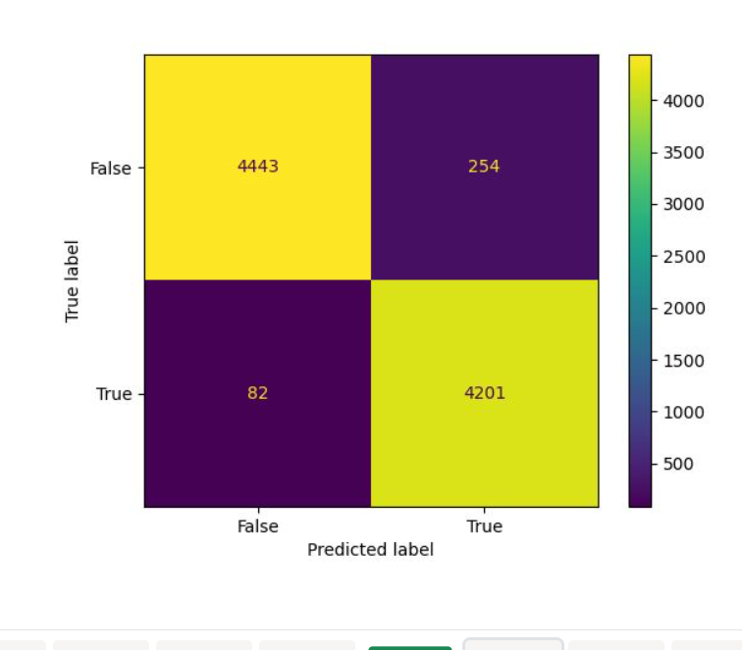 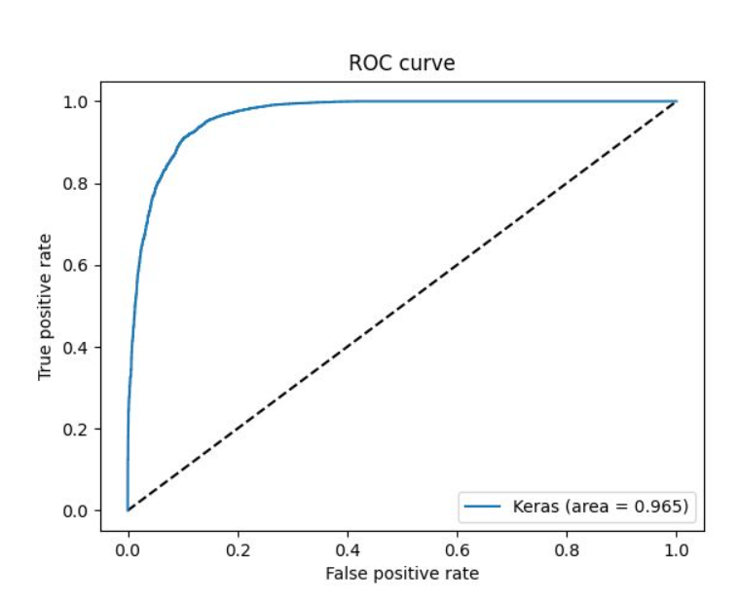

Fig 5.9: Confusion matrix for Real and Fake Fig 5.10: LSTM TPR vs FPR Graph

#### The graph in Figure 5.7 (Accuracy and Loss) illustrates the balance between learning and generalization during training.

#### It offers visual confirmation of the model’s stability and helps identify any signs of overfitting. Additionally, In the Above Figures 5.8 – 5.10 (Performance Metrics), ROC curves and confusion matrices offer a more nuanced understanding of how well the models separate real and fake news, supporting a deeper evaluation beyond simple accuracy.

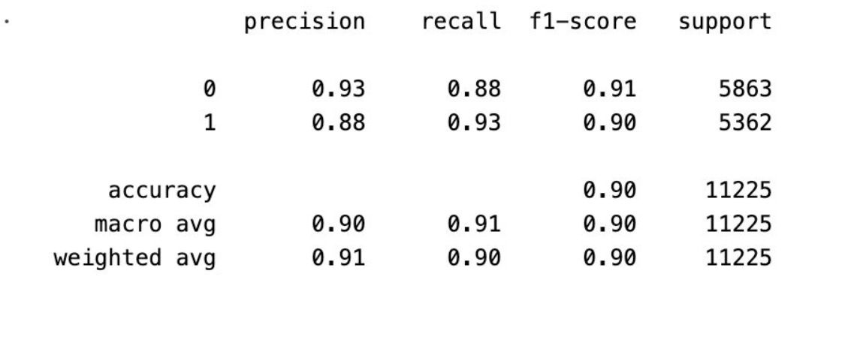

Fig 5.11: LSTM W2V Classification report

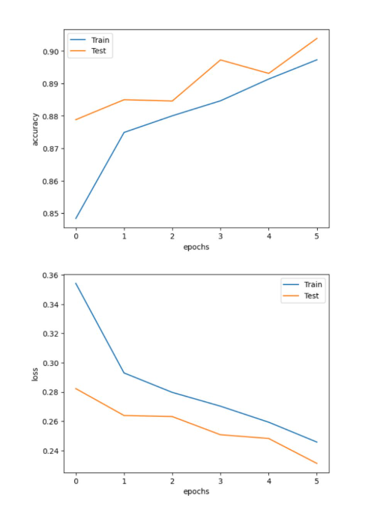

Fig 5.12: LSTM W2V Accuracy and loss graph

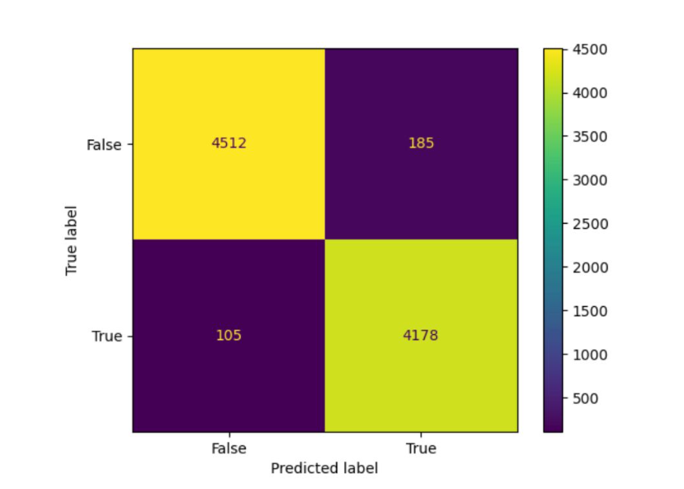

Fig 5.13: LSTM Glove Confusion matrix

The metrics Above Figures 5.11 – 5.13 (W2V & GloVe Evaluation) in the validate the performance of deep learning models using different embeddings. They demonstrate how representation techniques influence classification quality.

* 1. **Model Evaluation for news classification:**

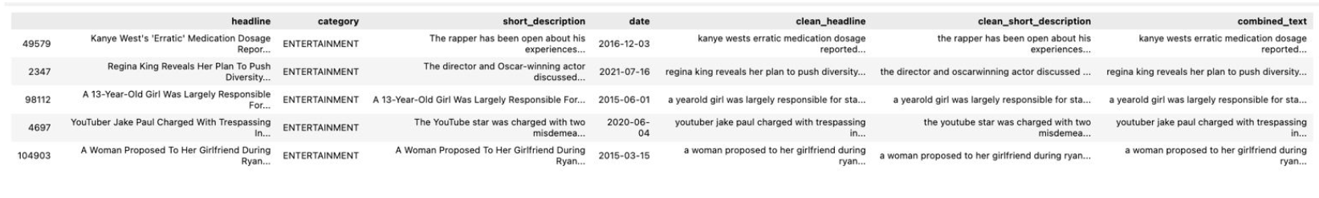

Fig 5.14: News Classification Dataset

For our hybrid deep model, a combination of Convolutional Neural Networks (CNN) and Bidirectional Long Short-Term Memory (BiLSTM) networks along with GloVe embeddings, we tested the model based on key performance measures including training accuracy, validation accuracy, precision, recall, and confusion matrix visualization. These metrics gave us an in-depth knowledge about the model's performance against different classes and pointed out the areas of misclassification.

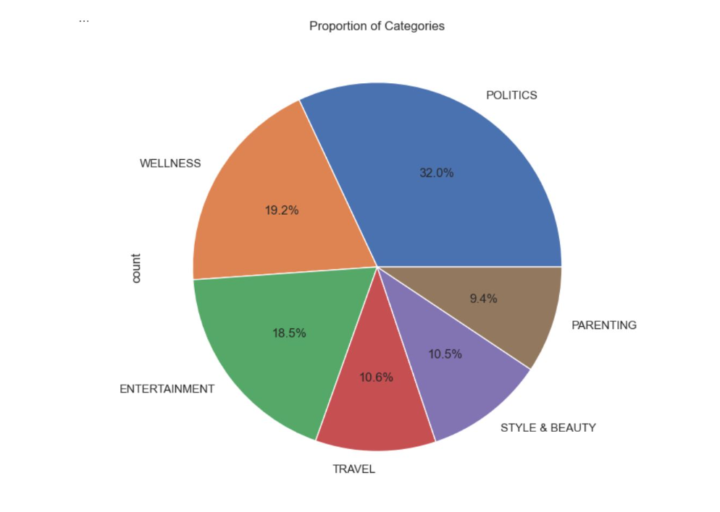

Fig 5.15: Pie chart Categories of Fake News

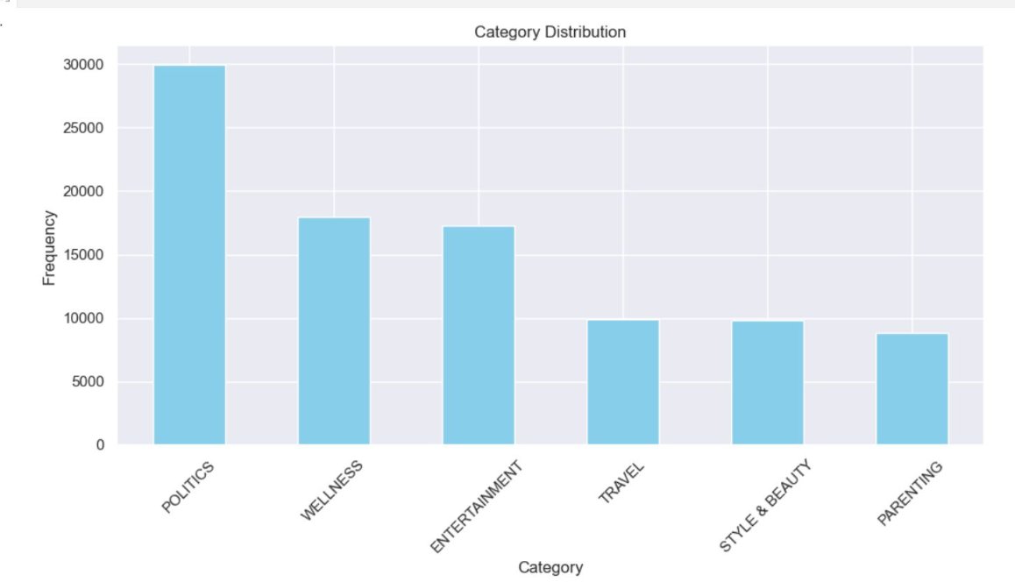

Fig 5.16: Bar Graph Categories of Fake News

These figures present the structure and diversity of the news classification dataset. Understanding the distribution of categories is essential for interpreting classification outcomes.

After extensive experimentation involving embedding selection and hyperparameter tuning, the best-performing model achieved an average accuracy of 88% with a loss value of 0.5861. The highest accuracy was observed when using GloVe embeddings, resulting in 95.50% accuracy on the training set and 88.28% on the testing set. This substantial performance highlights the effectiveness of GloVe in capturing semantic meaning for textual data in the context of fake news detection.

However, the noticeable gap between training and validation accuracy suggests the impact of an imbalanced dataset and training time optimization constraints, which may have contributed to minor overfitting. Addressing these issues through techniques such as data augmentation, resampling, or incorporating class weights could potentially improve the generalization ability of the model. Overall, the CNN-BiLSTM hybrid architecture, empowered by GloVe embeddings, has proven to be a promising approach in the detection of fake news.

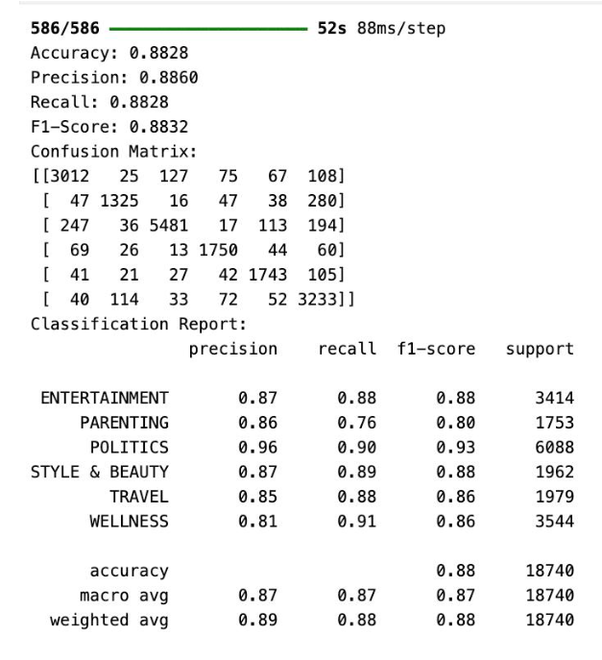

Fig 5.17: Classification Report

The classification report in Fig 5.17 summarizes the performance of a multi-class text classification model across six categories: ENTERTAINMENT, PARENTING, POLITICS, STYLE & BEAUTY, TRAVEL, and WELLNESS. The model achieved an overall accuracy of 88%, with a macro average F1-score of 0.87 and weighted average F1-score of 0.88, indicating balanced performance across categories. Notably, POLITICS showed the highest F1-score of 0.93, while PARENTING had the lowest at 0.80, suggesting room for improvement in classifying less-represented or more nuanced topics.

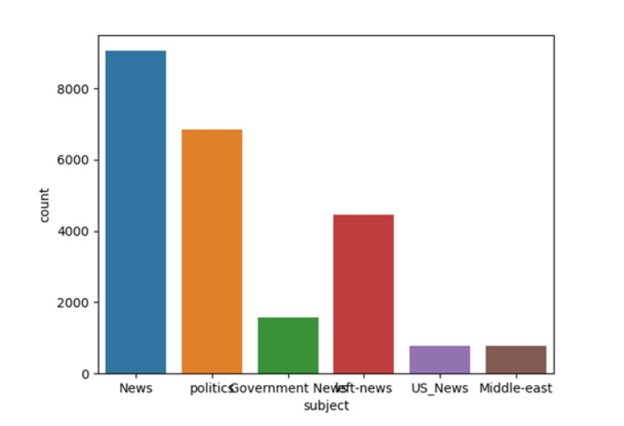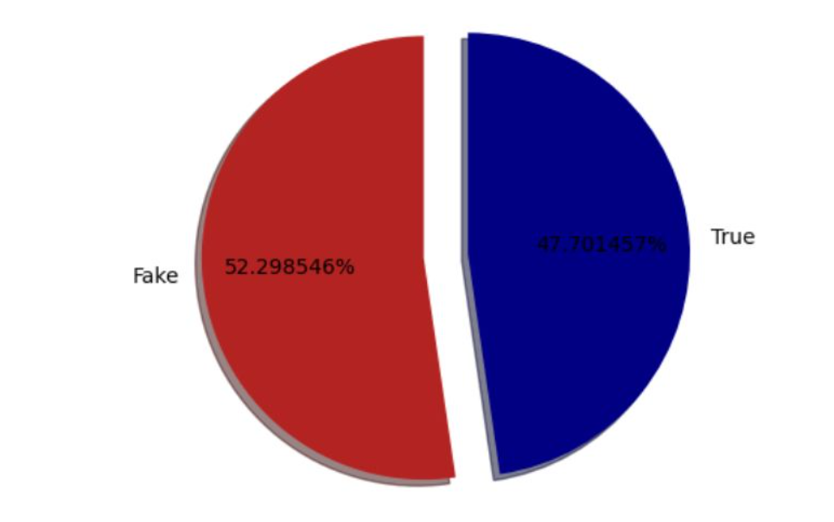

Fig 5.19: Distribution of News Articles by Subject Category in the Fake News Detection Dataset

Fig 5.18: Pie Chart representing Real vs Fake

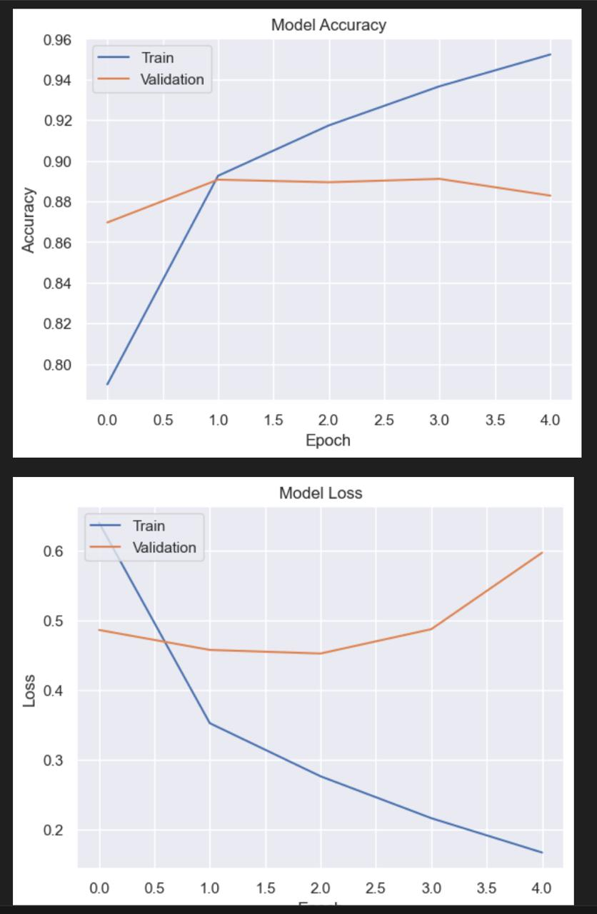 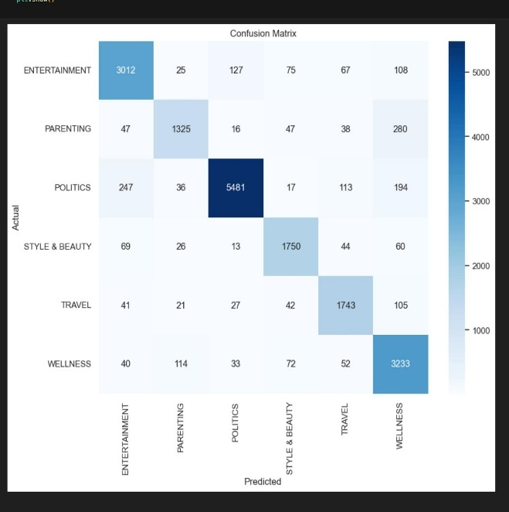

Fig 5.20: Accuracy and Loss Graph Fig 5.21: Confusion Matrix

The confusion matrix visualizes the performance of the multi-class classification model across six categories. It shows a strong diagonal dominance, indicating that most predictions align well with actual labels. For example, POLITICS has the highest correct predictions (5481), showing strong model confidence in that class. However, PARENTING and WELLNESS show noticeable misclassifications, especially with overlap between them (e.g., 280 PARENTING articles misclassified as WELLNESS).

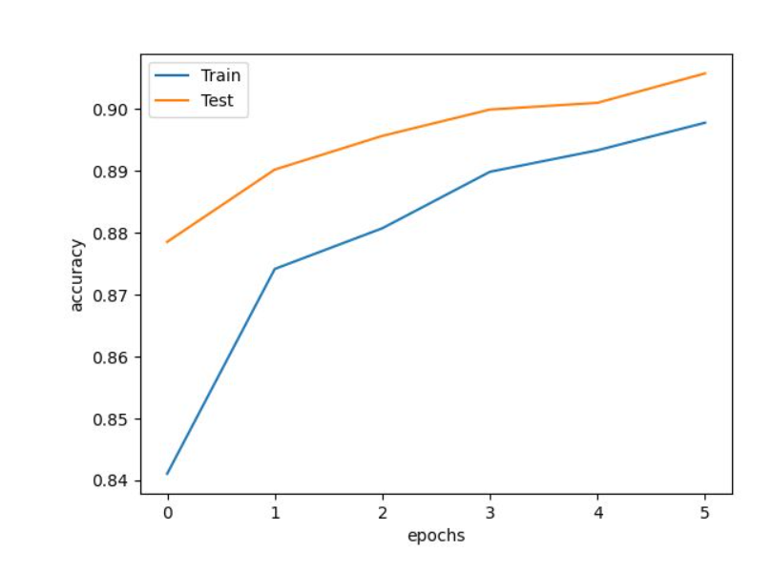

Fig 5.22: News classification Accuracy vs no. of epoch curve

Classification in different models:

This section benchmarks classical machine learning algorithms to understand their capabilities and limitations when compared to deep learning-based approaches.

To establish strong baseline performance and understand the behavior of classical models on the fake news dataset, we implemented and compared several traditional machine learning algorithms. These models are computationally efficient and offer interpretability, making them valuable in scenarios where resources are limited or model transparency is a priority. The models evaluated include:

* **Logistic Regression**
* **Decision Tree Classifier**
* **Gradient Boosting Classifier**
* **Random Forest Classifier**

Figures in this section visualize classification results from each of these models and include performance comparisons using metrics such as accuracy and ROC (Receiver Operating Characteristic) curves. The classification reports serve as a critical tool for understanding how each model performs not just in terms of overall accuracy, but also in their ability to correctly identify fake vs. real news across imbalanced classes. This comparison helps highlight the strengths and weaknesses of each approach—Logistic Regression’s simplicity and speed, Decision Tree’s interpretability, Gradient Boosting’s focus on hard-to-classify samples, and Random Forest’s ensemble strength. The insights gained here provide a foundation for justifying the transition to deep learning models explored in subsequent sections.

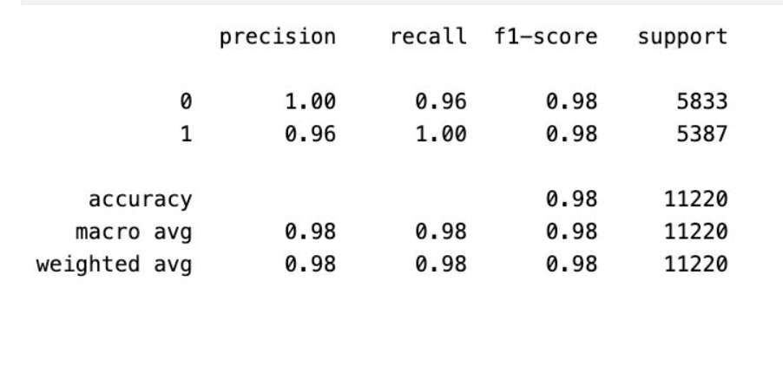

Fig 5.23: Logistic regression

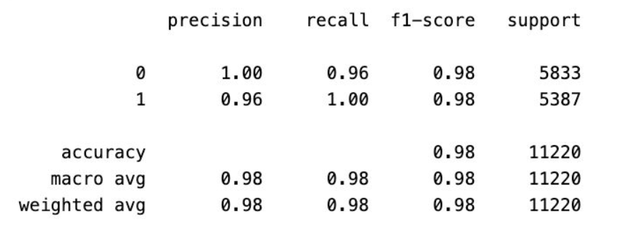

Fig 5.24: Decision tree

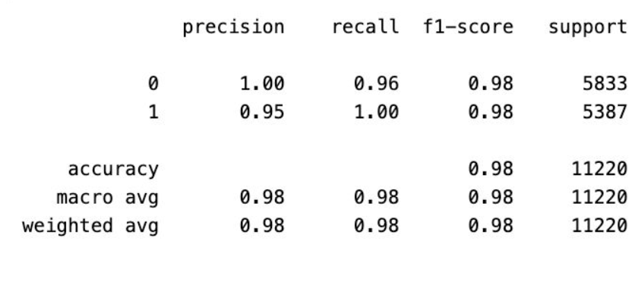

Fig 5.25: Gradient boosting

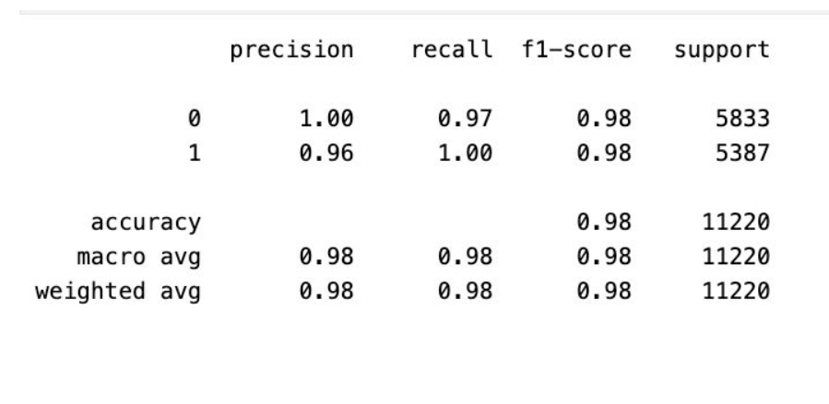

Fig 5.26: Random forest

The **ROC curve for the Random Forest model** is specifically highlighted to demonstrate its strong balance between true positive and false positive rates. These models help us assess how well non-deep-learning approaches perform in detecting fake news and provide a foundation for evaluating the added value of advanced neural models. By contrasting these traditional methods with deep learning architectures used later, we gain insights into trade-offs related to complexity, training time, generalizability, and predictive performance.

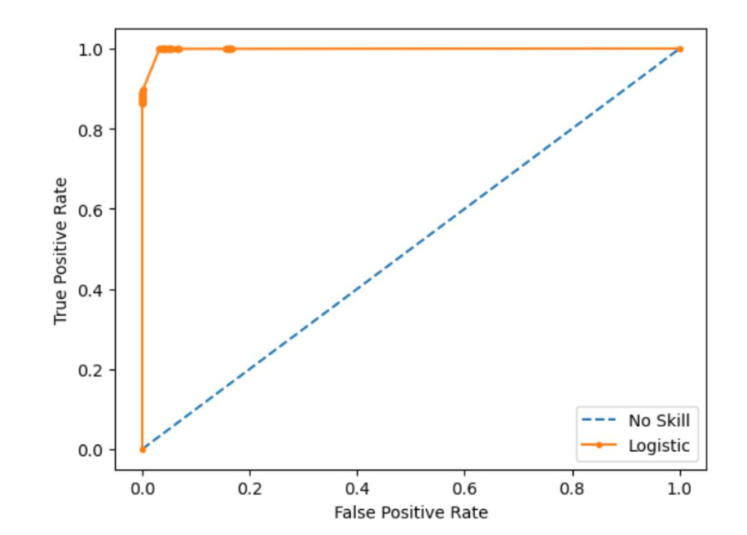

Fig 5.27: Roc curve random forest

**Deployment of flask app for fake news detection model and news classification model**

Out of all the models which we trained, the best trained model is deployed with the help of flask framework which facilitates the use of model for real time applications.

A simple website is made in HTML along with flask framework where we can give news as real time input and expect model to return accurate results.



Fig 5.28: HTML website

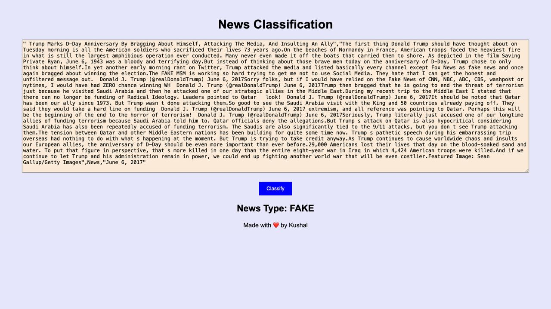

Fig 5.29: News Detection Frontend

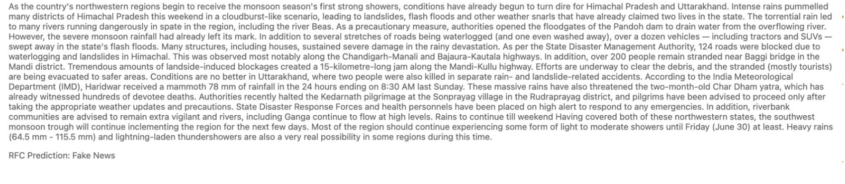

Fig 5.30: Fake news prediction result

These images showcase the real-world integration of our models through a simple web interface, confirming the practical viability and user accessibility of the system.

**5.3** **Deepfake audio and image detection:**

For both deepfake audio and image detection, we designed models that leverage multiple layers of convolutional neural networks (CNNs) combined with max pooling layers to effectively capture spatial and temporal features. These architectures were tailored to handle the complexities of both visual and auditory deepfake artifacts. In this evaluation, accuracy was used as the primary metric for assessing model performance.

In the case of deepfake image detection, the model achieved an impressive training accuracy of 99%, with a macro average accuracy of 98%, demonstrating its robustness in identifying manipulated visual content across different classes. This high accuracy indicates that the model successfully learned distinguishing features that differentiate between authentic and tampered images.

For deepfake audio detection, the model processed audio inputs by converting them into spectrograms, allowing the convolutional layers to analyze frequency-time patterns characteristic of voice manipulation. The audio detection model achieved a training accuracy of 90%, indicating effective learning of relevant acoustic features. Additionally, the Precision-Recall (PR) curve for this model yielded an AUC score of 0.87, reflecting strong performance in detecting deepfake audio across varying thresholds, especially in imbalanced settings where precision and recall are more informative than accuracy alone.

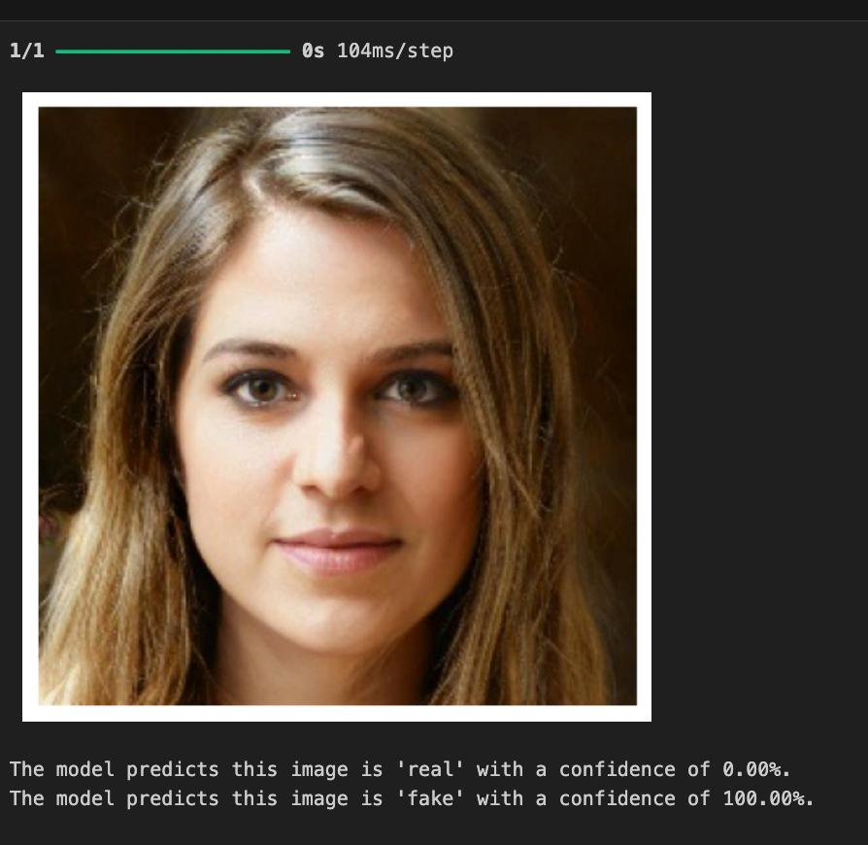

Fig 5.31: Image Detection

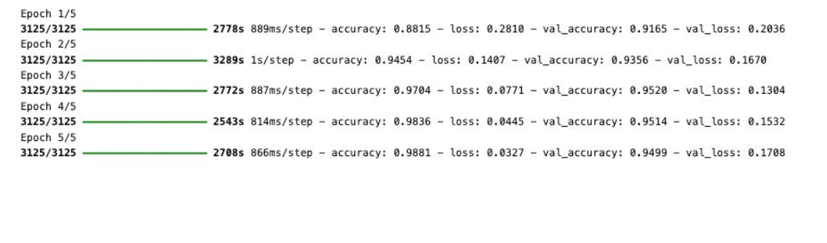

Fig 5.32: Image detection training loop

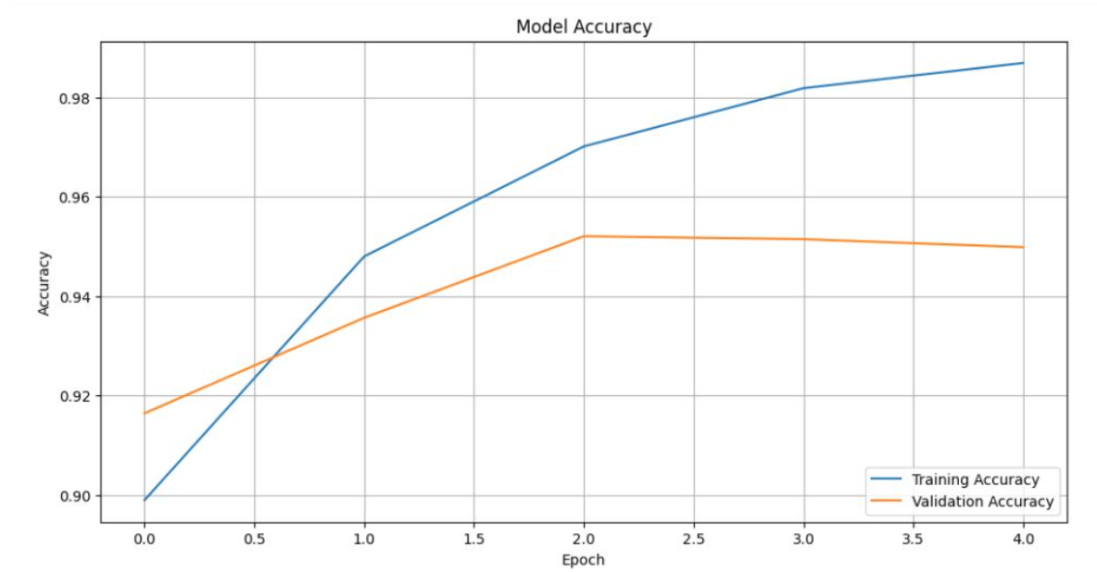

Fig 5.33: Image detection accuracy curve

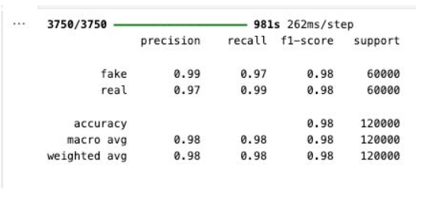

Fig 5.34: Image Detection Classification Report

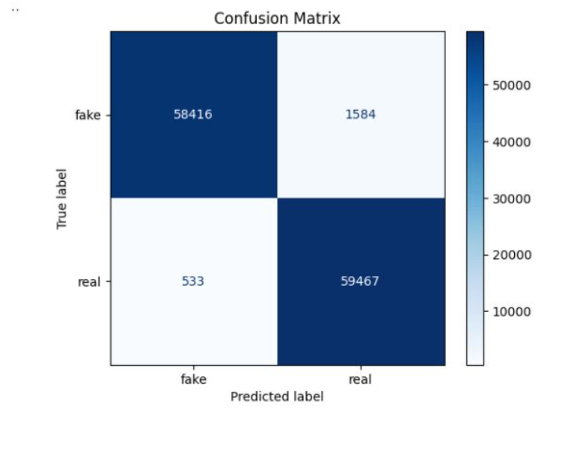

Fig 5.35: Image detection Confusion matrix

The deepfake image detection portion of the project is concerned with detecting manipulated or synthetic images via a convolutional neural network (CNN)-based model. The model was iteratively trained over a series of training iterations to learn important visual patterns that help it differentiate between real and synthetic images. The detection pipeline starts with input images that go through multiple convolution and pooling steps before finally resulting in a binary classification. Visual outputs produced by the model assist in verifying that it is able to successfully localize and classify tampered content. Figures pertaining to this section are an example of an image run through the detection model, training loop iteration, and an accuracy curve showing the consistency of the model's learning across epochs. Moreover, the classification report also gives precise metric-based performance feedback on performance—precision, recall, and F1-scores for both classes—while the confusion matrix also dissects correct and incorrect predictions. These two outputs collectively ensure the accuracy of the image detection system, pointing to its good performance, especially in recall and balanced classification results. The repeated training habit and large macro-average results indicate the model generalizes proficiently even with visually faint or highly compressed pseudo data.

The Mel spectrogram shown represents the time-frequency characteristics of an audio sample from the dataset, providing a visual representation of how energy is distributed across different frequencies over time. In this spectrogram, the x-axis denotes time (in seconds), while the y-axis represents frequency (in Hertz), ranging up to 4096 Hz. The color intensity encodes the amplitude of each frequency component, with brighter areas (yellow/orange) indicating higher energy and darker areas (purple/black) representing lower energy. This visualization is critical in deepfake audio detection, as it reveals patterns, harmonics, and spectral textures that are often imperceptible to the human ear but can be effectively leveraged by convolutional neural networks. The vertical striations and consistent frequency bands suggest periodic energy patterns typical of speech. However, anomalies such as unnaturally uniform textures or excessive harmonic alignment may hint at synthetically generated or manipulated audio. By converting raw audio into spectrograms like this, the model can better distinguish between authentic and fake samples based on their acoustic fingerprints.

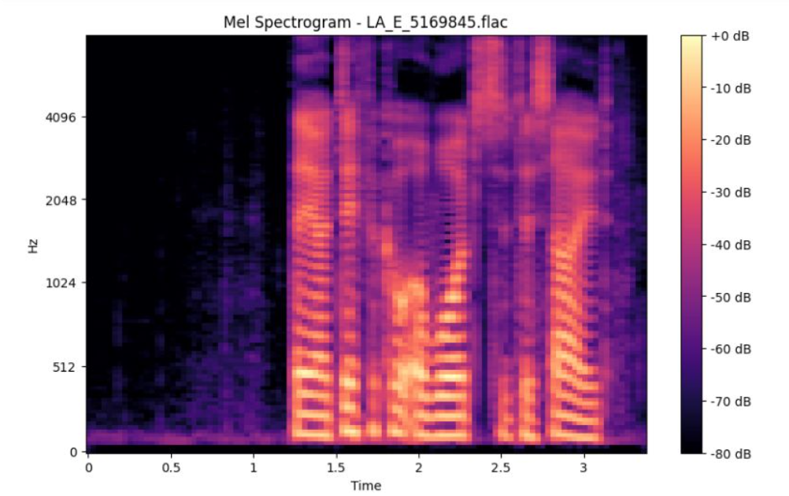

Fig 5.36: Audio detection example spectrogram

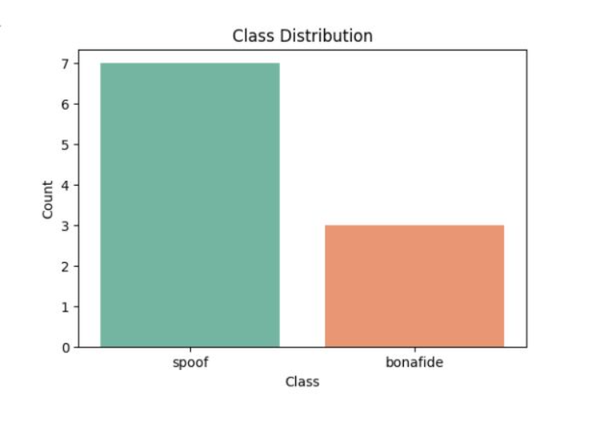

Fig 5.37: Audio detection data class distribution bar graph

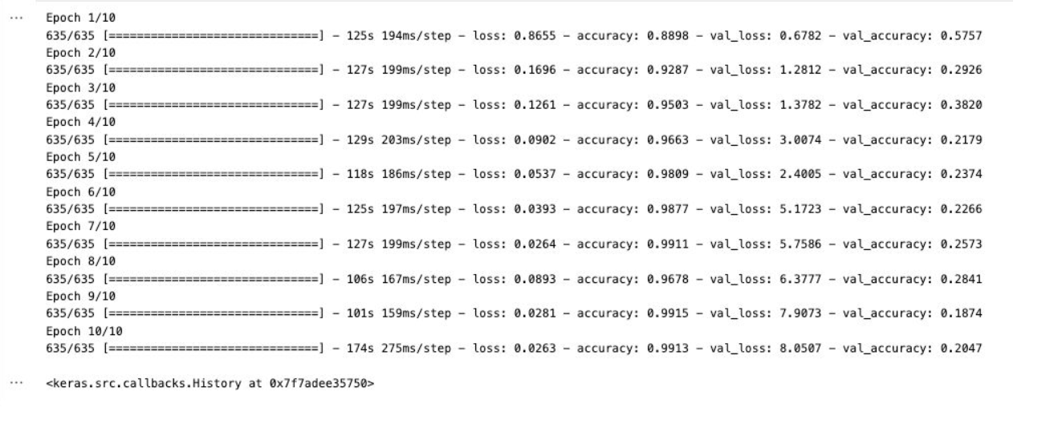

Fig 5.38: Audio detection training loop

The audio deepfake detection system takes a fundamentally different approach by transforming raw audio into spectrogram representations, which are then processed using CNN layers to detect synthetic speech patterns. Spectrograms visualize the frequency distribution over time, making it easier for the model to capture artifacts and inconsistencies typical in fake audio. The figures associated with this segment include sample spectrograms that depict the time-frequency characteristics of audio inputs, along with class distribution graphs that highlight the dataset composition. Understanding the distribution is critical for evaluating model fairness and preventing bias toward any class. The training loop graph visualizes the model's learning curve, revealing how performance evolves across epochs and whether the model reaches saturation or continues to improve.

# Chapter 6 Conclusion and Future Scope

This research set out to explore and enhance the detection of fake news through the integration of classical machine learning methods and advanced deep learning architectures, combined with the enrichment of the dataset using multiple data sources. Through this effort, we have demonstrated that a hybrid approach—merging traditional and modern techniques—can offer significant improvements in the classification accuracy, generalizability, and interpretability of fake news detection systems.

Our work began with identifying the limitations of the ISOT dataset and addressing them through the inclusion of additional, pre-processed datasets to create a more diverse and representative corpus. Classical supervised learning models, enhanced with feature engineering such as the "fake AI parameter," provided a solid baseline and offered meaningful insight into text-based classification. We then employed deep learning models, including CNNs, Bi-LSTMs, and BERT, which effectively captured contextual dependencies and linguistic subtleties, delivering improved accuracy and robustness.

Furthermore, the inclusion of optimization strategies like Bayesian Optimization and the Grasshopper Algorithm contributed to scalability, while attention mechanisms in our hybrid deep model brought interpretability to the forefront. The system is not only capable of high-performance classification but also holds the potential for real-time deployment in digital ecosystems, including social media and browser plugins.

This research contributes a unified framework that merges data engineering, model optimization, and neural network-based language modeling for a practical and deployable solution in misinformation detection. Its significance lies in the timely relevance of the issue—fake news continues to distort public discourse, misinform society, and influence real-world events. Our system, therefore, offers a step forward in combating this digital challenge.

The successful implementation of the proposed system for detecting fake news from cyber propaganda is anticipated to yield the following outcomes:

1. **Accurate Classification:** The model should achieve high accuracy, precision, recall, and F1 score metrics, indicating effective differentiation between real and fake news articles.
2. **Robust Model Performance:** The hybrid architecture combining CNN, Bi-LSTM, and attention mechanisms is expected to outperform traditional machine learning models and standalone deep learning models in terms of accuracy and generalization.
3. **Insights into Misinformation Patterns:** Analysis of model predictions may reveal common patterns or linguistic features prevalent in fake news articles, contributing to a better understanding of misinformation tactics.
4. **Scalability and Efficiency:** The use of optimization techniques like Bayesian Optimization and Grasshopper Algorithm should result in a scalable model that can handle large datasets efficiently while maintaining performance.
5. **Real-time Detection Capability:** The model can potentially be integrated into a web application or social media platform for real-time fake news detection, aiding users in identifying misinformation as they encounter it.
6. **Public Awareness and Education:** The project may contribute to raising public awareness about fake news and the importance of verifying information sources, fostering a more informed society.
7. **Foundation for Future Research:** The research can serve as a foundational study for further exploration of fake news detection methodologies, including the application of newer architectures like Transformers or advancements in unsupervised learning techniques.

By accomplishing these expected outcomes, the project will not only contribute to the field of fake news detection but also provide practical solutions to combat misinformation in the digital age.

Looking ahead, the research opens several avenues for further exploration. Future work may involve extending the system to support multilingual datasets, incorporating multimodal inputs such as images and videos, and exploring transformer-based or unsupervised learning architectures for even greater adaptability. The implementation of real-time detection systems and integration with major digital platforms could translate this research into tangible societal impact.

In the future, our approach to identifying false news and categorizing news can evolve in a number of important ways. First, expanding the dataset to encompass more diverse domains and global sources will be critical. This includes the integration of multilingual data and regional data to improve model generalizability and performance on global news sources. Second, integrating multi-modal data—e.g., images, video, and social signals—will continue to improve the system in identifying subtle cues and contextual patterns indicative of deceptive content.

Instead of going for a different dataset as this dataset doesn't have much info about the authenticity of the sources and we can actually create better models using the attention mechanism and give more weightage to other features rather than only focusing on the label and the context. Also, a method which would be able to support our decisions by displaying links related to the context done with the help of APIs & web scraping.

Further work on explainable artificial intelligence (XAI) can increase transparency in the decision-making process, thus increasing user trust and enabling stakeholders to understand the rationale behind classification outcomes. Future versions can also focus on real-time processing ability, allowing for timely detection and action against misinformation on rapidly evolving social media and news sites. Further enhancement of the "fake AI parameter" and adjustment of the ensemble of traditional and deep learning models can also enhance accuracy and robustness. Lastly, collaboration with media partners and media companies to roll out and test the system at scale will acquire valuable real-world experience, making the solution dynamic to evolving challenges in the digital news space. This continuous tuning will allow for the creation of a more robust, efficient, and transparent system for fighting misinformation in real-world use.

In conclusion, this thesis has laid the groundwork for a comprehensive, scalable, and effective fake news detection system. It not only contributes to the academic field of misinformation detection but also presents a practical tool to empower users, raise awareness, and support the broader fight against digital deception.Bibliography

# 

|  |  |
| --- | --- |
| [1] | A. Kumar, S. Kumar, A. Mallik, and R. R. Singh, “OptNet-Fake: Fake News Detection in Socio-Cyber Platforms Using Grasshopper Optimization and Deep Neural Network,” 2024. |
| [2] | M. Park and S. Chai, “Constructing a User-Centered Fake News Detection Model by Using Classification Algorithms in ML Techniques,” IEEE Access, volume 11, 2023. |
| [3] | X. Wang, W. Zhang, and X. Tang, “Coupled Information-Theoretic Encoding for Face Photo-Sketch Recognition,” Transactions on Information Forensics and Security IEEE, volume 7, no. 3, pp. 1210–1223, 2011. |
| [4] | D. Rohera, H. Shethna, K. Patel, U. Thakker, S. Tanwar, R. Gupta, W. C. Hong, and R. Sharma, “Fake News Classification Techniques Taxonomy: Aspects of Survey and Implementation,” IEEE Access, vol. 10, 2022. |
| [5] | M. A. Wani, I. M. Abuhaimed, A. Nayyar, A. Hussain, and A. A. E. El-Latif, “Toxic Fake News Detection and Classification for Combating COVID-19 Misinformation,” IEEE Trans. Comput. Social Syst., vol. 11, no. 4, 2024. |
| [6] | E. Hashmi, S. Y. Yayilgan, M. M. Yamin, S. Ali, and M. Abomhara, “Advancing Detection of Fake News: Hybrid Deep Learning With FastText and Explainable AI,” IEEE Access, vol. 12, 2024. |
| [7] | A. Oad, M. H. Farooq, A. Zafar, B. A. Akram, and R. Zhou, “Fake News Classification Methodology With Enhanced BERT,” IEEE Access, vol. 12, 2024. |
| [8] | H. L. Gururaj, H. Lakshmi, B. C. Soundarya, F. Flammini, and V. Janhavi, “ML-Based Approach for Fake News Detection,” Journal of ICT Standardization, volume 10, no. 4, 2022. |
| [9] | J. Wang, M. A. Akbar, J. P. Li, A. U. Haq, S. K. Khan, R. M. Alotaibi, and S. A. Alajlan, “SA-Bi-LSTM: Self Attention Fake News Detection With Bi-Directional LSTM-Based Intelligent Model for Accurate Detection,” IEEE Access, volume 12, 2024. |
| [10] | E. S. Apostol, V. I. Ilie, C. O. Truică, and A. Paschke, “Context-Aware Misinformation Detection: A Benchmark of Deep Learning Architectures Using Word Embeddings,” IEEE Access, volume 9, 2021. |
| [11] | M. Umer, Z. Imtiaz, A. Mehmood, S. Ullah, G. S. Choi, and B. W. On, “Fake News Stance Detection with Deep Learning Architecture (CNN-LSTM),” arXiv:1511.06434, 2015. |
| [12] | D. P. Kingma and J. Ba, “Adam: A Method for Stochastic Optimization,” IEEE Access, volume 8, 2020. |
| [13] | K. A. Qureshi, R. A. S. Malick, and M. S., “Complex Network and Source Inspired COVID-19 Fake News Classification on Twitter,” IEEE Access, vol. 9, 2021. |
| [14] | H. Ali, R. T. Javed, A. Qayyum, M. Alazmi, A. AlGhadhban, A. Alzamil, J. Qadir, and K. Al-Utaibi, “Robust Encrypted Inference in Deep Learning: A Pathway to Secure Misinformation Detection,” IEEE Trans. Depend. Secure Comput., vol. 22, no. 2, 2025. |
| [15] | Z. Ellaky, F. Benabbou, Y. Matrane, and S. Qaqa, “A Hybrid Deep Learning Architecture for Social Media Bots Detection Based on BiGRU-LSTM and GloVe Word Embedding,” IEEE Access, volume 12, 2024. |
| [16] | S. Kumar, A. Kumar, A. Mallik, and R. R. Singh, “OptNet-Fake: Fake News Detection in Socio-Cyber Platforms Using Grasshopper Optimization and Deep Neural Network,” 2024. |
| [17] | L. Hu, Z. Chen, Z. Zhao, J. Yin, and L. Nie, “Causal Inference for Leveraging Image-Text Matching Bias in Multi-Modal Fake News Detection,” 2023. |
| [18] | M. A. Wani, M. ElAffendi, A. Nayyar, K. A. Shakil, I. M. Abuhaimed, A. Hussain, and A. A. E. El-Latif, “Toxic Fake News Detection and Classification for Combating COVID-19 Misinformation,” IEEE, 2024. |
| [19] | P. Xu, Y. Huang, T. Yuan, K. Pang, Y.-Z. Song, T. Xiang, T. M. Hospedales, Z. Ma, and J. Guo, “SketchMate: Deep Hashing for Million-Scale Human Sketch Retrieval,” arXiv:1804.01401, 2018. |
| [20] | K. K. Jain, S. Grosz, A. M. Namboodiri, and A. K. Jain, “CLIP4Sketch: Enhancing Sketch to Mugshot Matching through Dataset Augmentation using Diffusion Models,” arXiv:2408.01233, 2024. |
| [21] | M. H. Sultan, M. S. Hossain, M. Safran, M. Alfarhood, and M. F. Mridha, “A Hybrid Attention-Based Transformer Model for Arabic News Classification Using Text Embedding and Deep Learning,” IEEE, 2024. |
| [22] | S. Guo, Y. Xu, and P. Liang, “Attention-Based Hybrid CNN-LSTM Model: Fake News Detection in Social Media,” IEEE Trans. Knowl. Data Eng., volume 33, no. 10, pp. 2106–2119, 2021. |
| [23] | X. Zhou, J. Han, and L. Hu, “Hybrid CNN-BiLSTM Model for Fake News Detection,” IEEE Access, volume 8, pp. 33826–33836, 2020. |
| [24] | Y. Li, X. Zhang, and Y. Zhao, “Optimizing CNN-BiLSTM Models with Grasshopper Optimization Algorithm for False News Detection,” IEEE Access, volume 9, pp. 43726–43738, 2021. |
| [25] | M. A. Wani, I. M. Abuhaimed, A. Nayyar, A. Hussain, and A. A. E. El-Latif, “Toxic Fake News Detection and Classification for Combating COVID-19 Misinformation,” IEEE Trans. Comput. Social Syst., vol. 11, no. 4, 2024. |
| [26] | G. K. Koru and Ç. Uluyol, “Detection of Turkish Fake News From Tweets With BERT Models,” *IEEE Access*, vol. 12, 2024. |
| [28] | K. Saini, N. K. Gupta, and R. Jain, “A Performance Evaluation of Glove Bi-LSTM and BERT based Deep Learning Approach for the Detection of Fake News,” *2023 5th Int. Conf. on Advances in Computing, Communication Control and Networking (ICAC3N)*, 2023. |
| [29] | A. Giachanou, G. Zhang, and P. Rosso, “Multimodal Multi-image Fake News Detection,” *2020 IEEE 7th Int. Conf. on Data Science and Advanced Analytics (DSAA)*, 2020. |
| [30] | D. H. Fouad, R. R. El-Sayed, and W. H. Gomaa, “Optimizing Text Classification: A Comparative Analysis of Pre-Trained Models and Custom Neural Network Architectures on the AuTextification Dataset,” *2024 Intelligent Methods, Systems, and Applications (IMSA)*, 2024. |
| [31] | T. Mitra and E. Gilbert, “A Knowledge-Based Deep Learning Approach for Automatic Fake News Detection using BERT on Twitter,” *Procedia Comput. Sci.*, vol. 207, pp. 1–8, 2024. |
| [32] | S. H. Saleh and A. Alharbi, “Fake News Detection Based on a Hybrid BERT and LightGBM Models,” *Complex Intell. Syst.*, vol. 9, no. 3, pp. 1234–1245, 2023. |
| [33] | R. Oshikawa, J. Qian, and W. Y. Wang, “Fake News Detection in Mainstream Media Using BERT,” in *Proc. Int. Conf. Comput. Process. Portuguese Lang.*, pp. 27–36, 2022. |
| [34] | V. N. Barbosa et al., “A Study of Algorithm-Based Detection of Fake News in Brazilian Election: Is BERT the Best?,” *IEEE Lat. Am. Trans.*, vol. 20, no. 5, pp. 789–796, 2022. |
| [35] | R. Nangi and K. V. Pradeepthi, “Combating Fake News with Machine Learning and Deep Learning Methods,” in *Proc. 2nd Int. Conf. Signal Data Process.*, pp. 28–35, 2023. |
| [36] | T. Saikh, A. De, A. Ekbal, and P. Bhattacharyya, “A Deep Learning Approach for Automatic Detection of Fake News,” in *Proc. 16th Int. Conf. Nat. Lang. Process.*, pp. 230–238, 2019. |
| [37] | Y. Wang et al., “Weak Supervision for Fake News Detection via Reinforcement Learning,” *arXiv preprint arXiv:1912.12520*, 2019. |
| [38] | X. Dong et al., “Deep Two-path Semi-supervised Learning for Fake News Detection,” *arXiv preprint arXiv:1906.05659*, 2019. |
| [39] | X. Zhang et al., “Mining Dual Emotion for Fake News Detection,” *arXiv preprint arXiv:1903.01728*, 2019. |
| [40] | O. Ajao, D. Bhowmik, and S. Zargari, “Fake News Identification on Twitter with Hybrid CNN and RNN Models,” *arXiv preprint arXiv:1806.11316*, 2018. |

*.*

##### Publication Details